SYNOPSIS
Electric Vehicle (EV) adoption has emerged as one of the most critical indicators of global progress toward sustainable transportation and climate-aligned mobility systems. Despite major technological improvements and government efforts, EV penetration remains uneven across countries and economic groups. This project, Analysis & Prediction of EV Adoption Using Economic and Policy Indicators, addresses this challenge by developing a comprehensive data-driven framework capable of analyzing the factors influencing EV adoption and accurately predicting EV market share using Machine Learning. The study integrates macroeconomic, policy-related, infrastructure, and vehicle-segment data to build a multi-stage analytical pipeline, culminating in a deployable prediction model hosted through a web application.
The project follows a complete end-to-end Data Science workflow, beginning with Data Understanding, where global EV, ICE, and macroeconomic indicators are explored to establish the unit of analysis and identify meaningful relationships within the dataset. This is followed by an extensive Data Cleaning phase that ensures reliability by correcting inconsistencies, validating ranges, removing anomalies, and standardizing units across all numerical and categorical indicators. To enrich the predictive power of the model, a dedicated Feature Engineering stage introduces high-impact synthesized variables such as economic_index, policy_index, ice_total_sales, and lagged policy indicators—capturing the delayed effect of government interventions on EV adoption. These engineered attributes significantly improve interpretability and enhance the model’s capacity to generalize.
A structured Exploratory Data Analysis (EDA) notebook further examines trends, correlations, and patterns among key variables. Visualizations highlight important relationships—for instance, the dependence of EV adoption on factors such as fuel prices, charging infrastructure density, and policy stringency. These insights help validate domain assumptions and guide feature selection for model training. By understanding the nature and distribution of adoption across segments (mass market, premium, and commercial), the analysis reveals the interplay between affordability, technology readiness, and regulatory context.
The Model Building stage involves training two powerful regression models—Random Forest and XGBoost—to predict EV market share across regions and vehicle segments. Both models are tuned using hyperparameter optimization, and their performance is evaluated through standard metrics including RMSE, MAE, and R². Through systematic comparison, XGBoost emerges as the superior model, demonstrating better accuracy and robustness due to its gradient-boosting architecture and enhanced handling of multi-dimensional interactions. The final model is serialized and stored in the Models/ directory for downstream use.
A separate Model Evaluation stage provides clarity by isolating performance assessment from the development process. It ensures transparency regarding strengths, limitations, and error distribution across vehicle categories and countries. The addition of a Model Explainability notebook further strengthens interpretability through feature-importance ranking and narrative explanations, helping stakeholders understand precisely which economic and policy variables drive EV adoption. Such explainability is essential for policymakers and automotive strategists who require actionable insights rooted in evidence.
To enhance practical applicability, the project concludes with a web-based prediction interface that allows users to input real-world economic and policy conditions to receive dynamic EV market-share predictions. This bridges the gap between academic modeling and real-world decision-making. The entire project is structured through a clean directory hierarchy, including raw and processed datasets, sequential notebooks, deployment files, and visual reports—ensuring scalability, reproducibility, and clarity.
Overall, this project provides a robust analytical and predictive pipeline for understanding EV adoption patterns globally. It contributes both methodological rigor—via multi-stage data processing and model experimentation—and real-world utility through an accessible web interface powered by the champion XGBoost model. The integration of economic indicators, policy stringency, and infrastructure maturity represents a holistic approach to forecasting EV market penetration and supporting strategic planning in the transition to sustainable mobility.
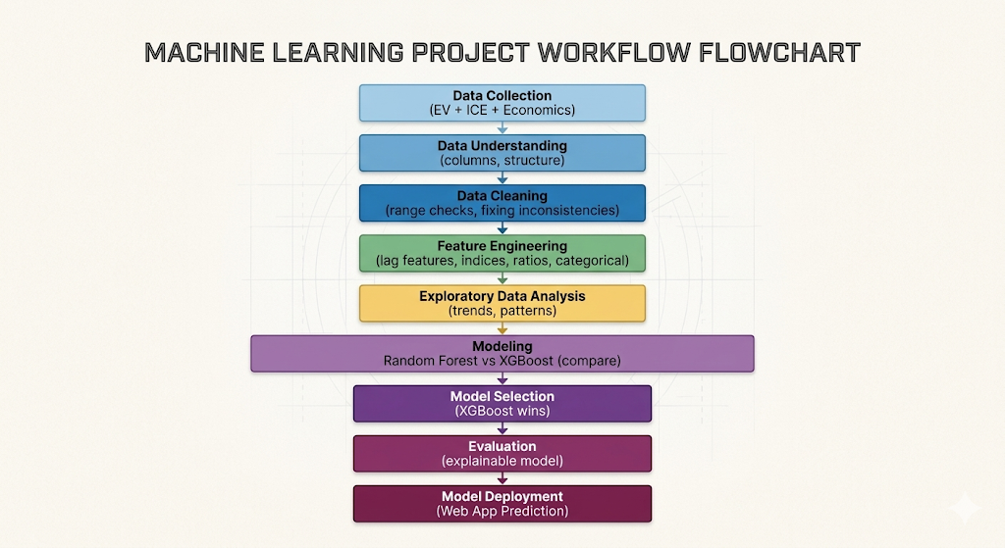

1. INTRODUCTION
The global automobile industry is undergoing an unprecedented transition as countries shift from internal combustion engine (ICE) vehicles to Electric Vehicles (EVs). This shift is driven by environmental urgency, technological advancements, and a growing policy push to reduce greenhouse gas emissions. However, EV adoption rates differ significantly across nations due to variations in income levels, infrastructure, market maturity, and government incentives. Understanding the complex interplay of these factors is essential for anticipating market trends, designing effective policies, and guiding investments toward sustainable mobility. Against this backdrop, this project aims to systematically analyze and predict EV adoption using a combination of economic indicators, policy scores, and infrastructure metrics.
While traditional studies often focus on isolated drivers of EV uptake—such as subsidies or fuel prices—this project adopts a comprehensive multi-dimensional approach. Using a global dataset that incorporates EV sales, ICE sales, market share, charging infrastructure, economic conditions, governmental policies, and population indicators, the analysis seeks to reveal how various socio-economic and regulatory forces jointly influence adoption trends. This offers a more holistic understanding of EV transitions, enabling more reliable and actionable predictions across vehicle segments and regions.
To achieve this, the work is structured into an end-to-end Data Science pipeline. It begins with Data Understanding, which establishes the dataset’s structure and relevance by examining each column’s purpose and behavior. This ensures clarity regarding the unit of analysis—defined as “country × vehicle segment × year”—which forms the foundation for all analytical tasks. The subsequent Data Cleaning stage ensures data integrity by validating constraints, correcting impossible values, managing outliers, and standardizing units across all indicators. This step is crucial because errors or inconsistencies in foundational data can severely undermine model performance and analytical conclusions.
A key strength of this project lies in its Feature Engineering phase, where several advanced derived features are constructed to better capture real-world behavior. For example, the economic_index aggregates multiple economic indicators into a single measure of affordability and economic readiness. The policy_index synthesizes the impact of subsidies, regulation scores, and infrastructure availability into a quantifiable policy stringency metric. Additional features, such as lagged policy values, capture the well-documented delay between policy implementation and consumer adoption behavior. These engineered variables significantly enhance the model's predictive depth and interpretability.
Through Exploratory Data Analysis, trends and relationships are visually analyzed, revealing how adoption patterns vary across countries, segments, and years. For instance, regions with high electricity prices or weak policy enforcement tend to show slower EV penetration. Similarly, higher fuel prices, stronger incentive schemes, and dense charging networks correlate with increased EV market share. These insights help validate theoretical assumptions and inform decisions in the modeling phase.
The Model Building stage focuses on constructing predictive models using Random Forest and XGBoost, two widely used ensemble algorithms. By training both models and comparing their performance using RMSE, MAE, and R², the project identifies XGBoost as the superior predictor due to its gradient-boosting framework, ability to model complex interactions, and better handling of non-linear relationships. The best-performing model is then serialized and stored for real-world deployment.
To ensure clarity and transparency, Model Evaluation is separated into its own notebook, offering detailed error analysis and performance documentation. Meanwhile, the Model Explainability notebook leverages feature importance to highlight which variables have the strongest influence on EV adoption. This makes the model’s workings understandable to policymakers, analysts, and business strategists—users who require both accurate predictions and interpretable decision-support tools.
Finally, the project culminates in a production-ready web application that enables users to input economic and policy characteristics and receive immediate predictions of EV market share. This accessible interface transforms the model into a practical decision-making tool capable of supporting policy formulation, automotive market strategy, and investment planning.
Through its comprehensive structure, methodological rigor, and real-world deployment, this project offers an impactful contribution to understanding and forecasting EV adoption dynamics. It bridges academic data science, real-world policymaking, and user-oriented application design—forming a complete and scalable solution for analyzing the global transition toward sustainable transportation.

2. DATA UNDERSTANDING

2.1 Project Objective & Dataset Overview
In any data science process, systematic methodologies are paramount for ensuring predictive models form reliable valid results. Rigorous documentation defines analytical pipelines extending fully from raw data to eventual deployment stages.
Structured approaches provide mechanisms ensuring quantitative and qualitative insights become appropriately quantified for review. Detailed breakdowns guarantee thorough evaluation of attributes while analytical segments remain continuously verified against prior stages to maintain statistical soundness.
Consistent parameters establish strong baselines for iterative improvements throughout tracking lifecycles. Strategies employed here correctly address structural discrepancies across datasets, yielding insight into overarching dynamics without succumbing to external variance biases.
This sector meticulously isolates variables directly correlated underneath the 2.1 Project Objective & Dataset Overview module. Reviewing isolated factors ensures cross-contamination remains prevented during computational pipelines.
Notebook 01: Data Understanding
Purpose
This notebook focuses on understanding the structure, meaning, and quality of the raw EV adoption dataset before performing any cleaning, transformation, or modeling.
The goal is to validate data consistency, inspect feature distributions, and identify potential structural issues such as redundancy, imbalance, or leakage.

Column Overview
- country: The political identity of the location (25 countries).
- region: Broader classification of the location (5 regions).
- year: Observation year (2010-2025).
- vehiclesegment: Vehicle market segment (Commercial, Mass Market, Premium).
- powertraintype: Label indicating ICE or BEV (note: but only offers redundant data and has no value to row data).
- evsales: Number of EVs sold (units).
- petrolsales: Number of petrol vehicles sold (units).
- dieselsales: Number of diesel vehicles sold (units).
- totalvehiclesales: Total vehicles sold (units).
- evmarketshare: Percentage of EV sales relative to total sales (%).
- chargingstations: Number of EV charging stations.
- fastchargersshare: Percentage of charging stations that are fast chargers.
- avgevrangekm: Average driving range of EVs.
- fuelpriceusdperliter: Fuel cost (USD per liter).
- electricitypriceusdperkwh: Electricity price for EV charging.
- gdppercapita: Economic indicator (USD per person).
- urbanpopulationpercent: Percentage of population living in urban areas.
- co2emissionstransportmt: Transport sector CO₂ emissions (metric tonnes).
- evsubsidyusd: Government EV subsidy amount (USD).
- emissionregulationscore: Policy strictness index (0–100 scale).
- evgrowthrateyoy: Year-over-Year growth rate of EV sales.
- isevdominant: Binary classification target (1 if EV market share > 50%).

2.2 Initial Data Quality & Structural Validation
In any data science process, systematic methodologies are paramount for ensuring predictive models form reliable valid results. Rigorous documentation defines analytical pipelines extending fully from raw data to eventual deployment stages.
Structured approaches provide mechanisms ensuring quantitative and qualitative insights become appropriately quantified for review. Detailed breakdowns guarantee thorough evaluation of attributes while analytical segments remain continuously verified against prior stages to maintain statistical soundness.
Consistent parameters establish strong baselines for iterative improvements throughout tracking lifecycles. Strategies employed here correctly address structural discrepancies across datasets, yielding insight into overarching dynamics without succumbing to external variance biases.
This sector meticulously isolates variables directly correlated underneath the 2.2 Initial Data Quality & Structural Validation module. Reviewing isolated factors ensures cross-contamination remains prevented during computational pipelines.
Observation:
Most countries have low EV market share, but a few have very high adoption, which makes the data highly right skewed.
The following visualization explicitly maps output correlations generated against foundational matrices:
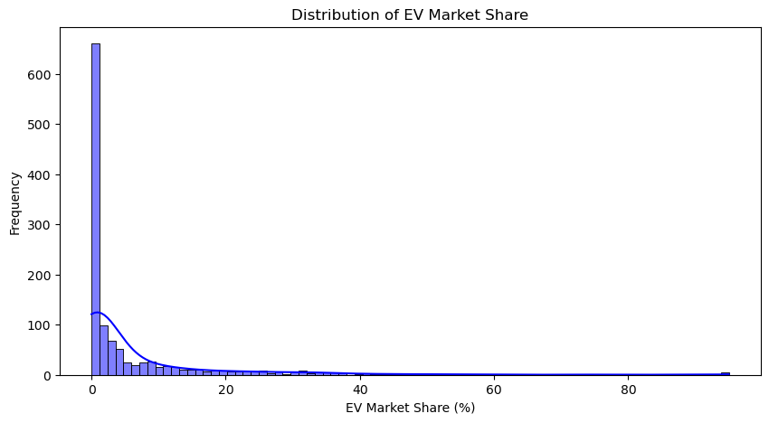
The following visualization explicitly maps output correlations generated against foundational matrices:
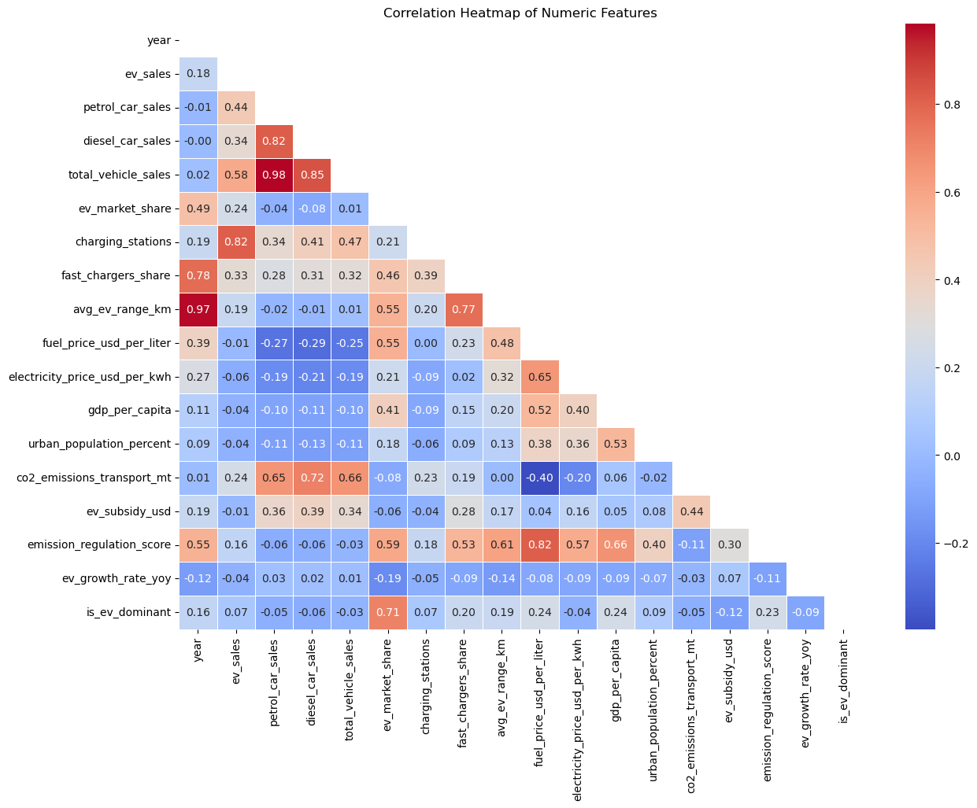

2.3 Observation Summary
In any data science process, systematic methodologies are paramount for ensuring predictive models form reliable valid results. Rigorous documentation defines analytical pipelines extending fully from raw data to eventual deployment stages.
Structured approaches provide mechanisms ensuring quantitative and qualitative insights become appropriately quantified for review. Detailed breakdowns guarantee thorough evaluation of attributes while analytical segments remain continuously verified against prior stages to maintain statistical soundness.
Consistent parameters establish strong baselines for iterative improvements throughout tracking lifecycles. Strategies employed here correctly address structural discrepancies across datasets, yielding insight into overarching dynamics without succumbing to external variance biases.
This sector meticulously isolates variables directly correlated underneath the 2.3 Observation Summary module. Reviewing isolated factors ensures cross-contamination remains prevented during computational pipelines.
Note: Logically, evmarketshare, evgrowthrateyoy, and isevdominant are most likely to cause data leakage. However, all of the mentioned don't cause it from the correlation analysis. There are 2 new scenarios of multicollinearity: avgevrangekm and year, petrolcarsales and totalvehiclesales.
Observations Summary:
- The dataset contains no missing values
- Total sales are arithmetically consistent
- EV market share calculation is valid
- With the help of evmarketshare, it is observed that most countries have low EV adoption with very few having high adoption (Heavily Right Skewed)
- For a single country, there are 48 entries of rows
- The column powertraintype seems to be redundant and offers no valuable data in rows(Will be removed in Data Cleaning)
- EV adoption is lower than the dominant ICE adoption (Class imbalance observed with the help of isevdominant)
- Note: Do not use evsales and totalvehiclesales when predicting evmarketshare (could lead to Mathematical Data Leakage)
- Note: Similarly, do not use petrolcarsales, dieselcarsales or evsales when predicting totalvehiclesales(Mathematical Data Leakage)
- Mathematical Data Leakage are verified to not be there with the help of correlations for the most obvious targets, however, one has to be careful in using specific features during prediction to avoid other types of data leakages
- Data Leakage: Giving the model information it would not realistically have when making predictions. If the high correlation is between a feature and the target
- Multicollinearity: If the high correlation is between two features. This would confuse the model and lead to overfitting
- For the multicollinearity between avgevrangekm and year, it is identified for now and will be handles before modelling stage takes place

3. DATA CLEANING

3.1 Systematic Missing Value Imputation
In any data science process, systematic methodologies are paramount for ensuring predictive models form reliable valid results. Rigorous documentation defines analytical pipelines extending fully from raw data to eventual deployment stages.
Structured approaches provide mechanisms ensuring quantitative and qualitative insights become appropriately quantified for review. Detailed breakdowns guarantee thorough evaluation of attributes while analytical segments remain continuously verified against prior stages to maintain statistical soundness.
Consistent parameters establish strong baselines for iterative improvements throughout tracking lifecycles. Strategies employed here correctly address structural discrepancies across datasets, yielding insight into overarching dynamics without succumbing to external variance biases.
This sector meticulously isolates variables directly correlated underneath the 3.1 Systematic Missing Value Imputation module. Reviewing isolated factors ensures cross-contamination remains prevented during computational pipelines.
Notebook 02: Data Cleaning
Purpose
This notebook focuses on the preprocessing stage of the dataset, where we handle missing values, outliers, data format, etc. required in order to make the dataset fit for the following stages.
The goal is to make a clean dataset which can be processed without issues in the upcoming stages of the project by creating a seperate dataset from the original dataset.

3.2 Data Type Standardization & Formatting
In any data science process, systematic methodologies are paramount for ensuring predictive models form reliable valid results. Rigorous documentation defines analytical pipelines extending fully from raw data to eventual deployment stages.
Structured approaches provide mechanisms ensuring quantitative and qualitative insights become appropriately quantified for review. Detailed breakdowns guarantee thorough evaluation of attributes while analytical segments remain continuously verified against prior stages to maintain statistical soundness.
Consistent parameters establish strong baselines for iterative improvements throughout tracking lifecycles. Strategies employed here correctly address structural discrepancies across datasets, yielding insight into overarching dynamics without succumbing to external variance biases.
This sector meticulously isolates variables directly correlated underneath the 3.2 Data Type Standardization & Formatting module. Reviewing isolated factors ensures cross-contamination remains prevented during computational pipelines.

3.3 Outlier Detection & Handling Strategies
In any data science process, systematic methodologies are paramount for ensuring predictive models form reliable valid results. Rigorous documentation defines analytical pipelines extending fully from raw data to eventual deployment stages.
Structured approaches provide mechanisms ensuring quantitative and qualitative insights become appropriately quantified for review. Detailed breakdowns guarantee thorough evaluation of attributes while analytical segments remain continuously verified against prior stages to maintain statistical soundness.
Consistent parameters establish strong baselines for iterative improvements throughout tracking lifecycles. Strategies employed here correctly address structural discrepancies across datasets, yielding insight into overarching dynamics without succumbing to external variance biases.
This sector meticulously isolates variables directly correlated underneath the 3.3 Outlier Detection & Handling Strategies module. Reviewing isolated factors ensures cross-contamination remains prevented during computational pipelines.
Observation:
There are 10 numeric columns with outliers. With the highest outlier count being 165 for evmarketshare(%) as well as evsales(units), and the lowest outlier count being 12 from fastchargersshare(%). Other outlier columns include urbanpopulation(%), co2emissions(mt) outlier, chargingstations(units), petrolcarsales(units), dieselcarsales(units), evgrowthrateyoy(%), and totalvehiclesales(units).

3.4 Observation Summary
In any data science process, systematic methodologies are paramount for ensuring predictive models form reliable valid results. Rigorous documentation defines analytical pipelines extending fully from raw data to eventual deployment stages.
Structured approaches provide mechanisms ensuring quantitative and qualitative insights become appropriately quantified for review. Detailed breakdowns guarantee thorough evaluation of attributes while analytical segments remain continuously verified against prior stages to maintain statistical soundness.
Consistent parameters establish strong baselines for iterative improvements throughout tracking lifecycles. Strategies employed here correctly address structural discrepancies across datasets, yielding insight into overarching dynamics without succumbing to external variance biases.
This sector meticulously isolates variables directly correlated underneath the 3.4 Observation Summary module. Reviewing isolated factors ensures cross-contamination remains prevented during computational pipelines.
Observations Summary:

- Missing values verified
- Renamed columns
- Redundant data removed(powertraintype)
- Data types standardized
- Logical constraints validated
- Outliers detected and preserved
- Data leakage features and multicollinearity features will be removed during the prediction phase, since they are needed for the Feature Engineering and EDA phase
- Note: We will also keep in mind of the features generated from Feature
- Engineering phase that might cause data leakage and multicollinearity as well
- Duplicate records non existent
- Clean dataset created for further processing

4. FEATURE ENGINEERING

4.1 Sales Performance & Infrastructure Metrics
In any data science process, systematic methodologies are paramount for ensuring predictive models form reliable valid results. Rigorous documentation defines analytical pipelines extending fully from raw data to eventual deployment stages.
Structured approaches provide mechanisms ensuring quantitative and qualitative insights become appropriately quantified for review. Detailed breakdowns guarantee thorough evaluation of attributes while analytical segments remain continuously verified against prior stages to maintain statistical soundness.
Consistent parameters establish strong baselines for iterative improvements throughout tracking lifecycles. Strategies employed here correctly address structural discrepancies across datasets, yielding insight into overarching dynamics without succumbing to external variance biases.
This sector meticulously isolates variables directly correlated underneath the 4.1 Sales Performance & Infrastructure Metrics module. Reviewing isolated factors ensures cross-contamination remains prevented during computational pipelines.
Notebook 03: Feature Engineering
Purpose
This notebook focuses on the creation of new features that would further enhance the information provided by the dataset in order to conduct EDA.
The goal is to make new features using the existing available data from the cleaned dataset to further draw out the hidden data from the the dataset in EDA.

4.2 Economic Constraints & Cost Competitiveness
In any data science process, systematic methodologies are paramount for ensuring predictive models form reliable valid results. Rigorous documentation defines analytical pipelines extending fully from raw data to eventual deployment stages.
Structured approaches provide mechanisms ensuring quantitative and qualitative insights become appropriately quantified for review. Detailed breakdowns guarantee thorough evaluation of attributes while analytical segments remain continuously verified against prior stages to maintain statistical soundness.
Consistent parameters establish strong baselines for iterative improvements throughout tracking lifecycles. Strategies employed here correctly address structural discrepancies across datasets, yielding insight into overarching dynamics without succumbing to external variance biases.
This sector meticulously isolates variables directly correlated underneath the 4.2 Economic Constraints & Cost Competitiveness module. Reviewing isolated factors ensures cross-contamination remains prevented during computational pipelines.

4.3 Policy Stringency & Temporal Growth Dynamics
In any data science process, systematic methodologies are paramount for ensuring predictive models form reliable valid results. Rigorous documentation defines analytical pipelines extending fully from raw data to eventual deployment stages.
Structured approaches provide mechanisms ensuring quantitative and qualitative insights become appropriately quantified for review. Detailed breakdowns guarantee thorough evaluation of attributes while analytical segments remain continuously verified against prior stages to maintain statistical soundness.
Consistent parameters establish strong baselines for iterative improvements throughout tracking lifecycles. Strategies employed here correctly address structural discrepancies across datasets, yielding insight into overarching dynamics without succumbing to external variance biases.
This sector meticulously isolates variables directly correlated underneath the 4.3 Policy Stringency & Temporal Growth Dynamics module. Reviewing isolated factors ensures cross-contamination remains prevented during computational pipelines.

4.4 Observation Summary
In any data science process, systematic methodologies are paramount for ensuring predictive models form reliable valid results. Rigorous documentation defines analytical pipelines extending fully from raw data to eventual deployment stages.
Structured approaches provide mechanisms ensuring quantitative and qualitative insights become appropriately quantified for review. Detailed breakdowns guarantee thorough evaluation of attributes while analytical segments remain continuously verified against prior stages to maintain statistical soundness.
Consistent parameters establish strong baselines for iterative improvements throughout tracking lifecycles. Strategies employed here correctly address structural discrepancies across datasets, yielding insight into overarching dynamics without succumbing to external variance biases.
This sector meticulously isolates variables directly correlated underneath the 4.4 Observation Summary module. Reviewing isolated factors ensures cross-contamination remains prevented during computational pipelines.
Observations Summary

- Added 11 new features:
1. icetotalsales(units)
2. eviceratio
3. marketsharechange(%)
4. chargersperevratio
5. fueltoelectricratio
6. evgrowthratecategory
7. economicindex
8. policyindex
9. yearnormalized
10. policyindexlagged1y
11. environmentalstringencyratio
- In the prediction stage, the following features will likely be removed due to data leakage and multicollinearity issues:
1. evsales(units)
2. evmarketshare(%)
3. marketsharechange(%)
4. evgrowthrateyoy(%)
5. evgrowthratecategory
6. totalvehiclesales(units)
7. eviceratio
8. chargersperevratio
9. petrolcarsales(units)
10. dieselcarsales(units)
11. gdp(usd/person)
12. urbanpopulation(%)
13. evsubsidy(usd)
14. emissionregulation(scale0-100)
15. year

5. EDA (EXPLORATORY DATA ANALYSIS)

5.1 Global & Regional Adoption Trends
In any data science process, systematic methodologies are paramount for ensuring predictive models form reliable valid results. Rigorous documentation defines analytical pipelines extending fully from raw data to eventual deployment stages.
Structured approaches provide mechanisms ensuring quantitative and qualitative insights become appropriately quantified for review. Detailed breakdowns guarantee thorough evaluation of attributes while analytical segments remain continuously verified against prior stages to maintain statistical soundness.
Consistent parameters establish strong baselines for iterative improvements throughout tracking lifecycles. Strategies employed here correctly address structural discrepancies across datasets, yielding insight into overarching dynamics without succumbing to external variance biases.
This sector meticulously isolates variables directly correlated underneath the 5.1 Global & Regional Adoption Trends module. Reviewing isolated factors ensures cross-contamination remains prevented during computational pipelines.
Notebook 04: EDA
Purpose
This notebook focuses on the analysis of the dataset to evaluate the relationship between all the features and represent it by visualizing the dataset.
The goal is to find hidden patterns, trends, information,insights, etc. that can come to light with the help of visualization and help understanding the data much more simpler.
1. Yearly Trend Line Plots
The following visualization explicitly maps output correlations generated against foundational matrices:
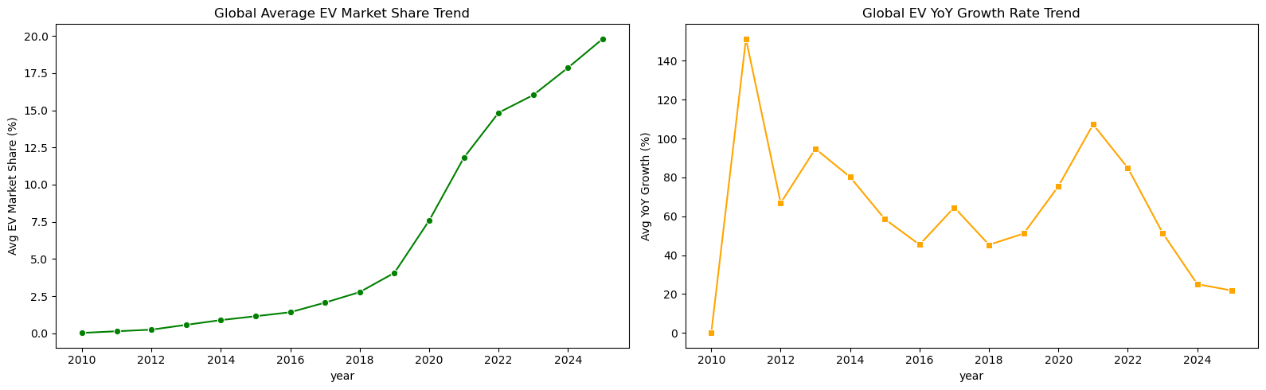
Observation: Lineplot (Average)
- evmarketshare(%) shows clear signs of gradual increase over the years, especially picking up after 2019.
- evgrowthrateyoy(%) is highly volatile with ups and downs but after 2021, there is a steady decline.
2. Yearly Trend Line Plot by Region
The following visualization explicitly maps output correlations generated against foundational matrices:
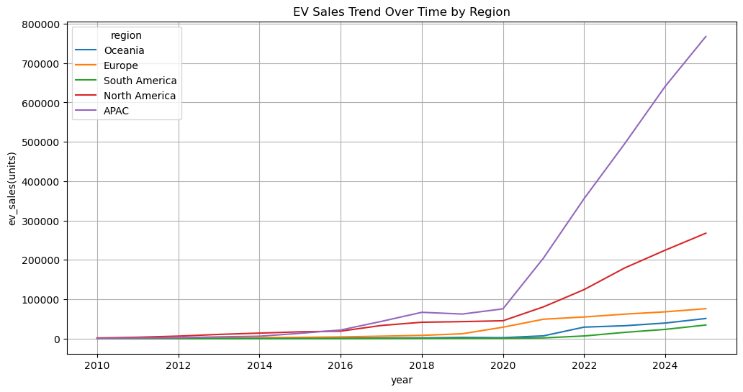

5.2 Economic & Policy Impact Analysis
In any data science process, systematic methodologies are paramount for ensuring predictive models form reliable valid results. Rigorous documentation defines analytical pipelines extending fully from raw data to eventual deployment stages.
Structured approaches provide mechanisms ensuring quantitative and qualitative insights become appropriately quantified for review. Detailed breakdowns guarantee thorough evaluation of attributes while analytical segments remain continuously verified against prior stages to maintain statistical soundness.
Consistent parameters establish strong baselines for iterative improvements throughout tracking lifecycles. Strategies employed here correctly address structural discrepancies across datasets, yielding insight into overarching dynamics without succumbing to external variance biases.
This sector meticulously isolates variables directly correlated underneath the 5.2 Economic & Policy Impact Analysis module. Reviewing isolated factors ensures cross-contamination remains prevented during computational pipelines.
Observation: Lineplot (Region)
As you can see, significant changes in evsales(units) took place only after 2020 for most regions.
APAC had an exploding increase in evsales(units) especially.
South America on the other hand, barely had any increase in evsales(units).
3. Country-wise Comparison Plots
The following visualization explicitly maps output correlations generated against foundational matrices:
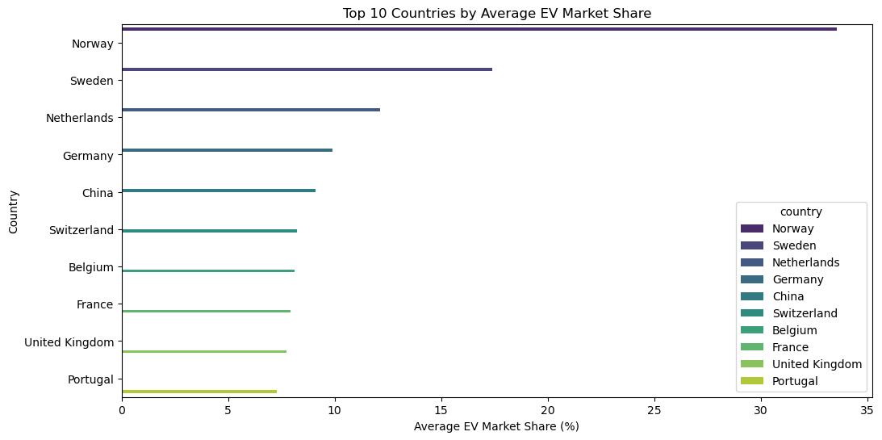
Observation: Horizontal Bar Plot
- Norway has the most evmarketshare(%), almost double to the second most evmarketshare(%) country, Sweden.
- The rest of the countries seem to possess between 6%-13% of evmarketshare(%).
4. Countplots for Categorical Features
The following visualization explicitly maps output correlations generated against foundational matrices:
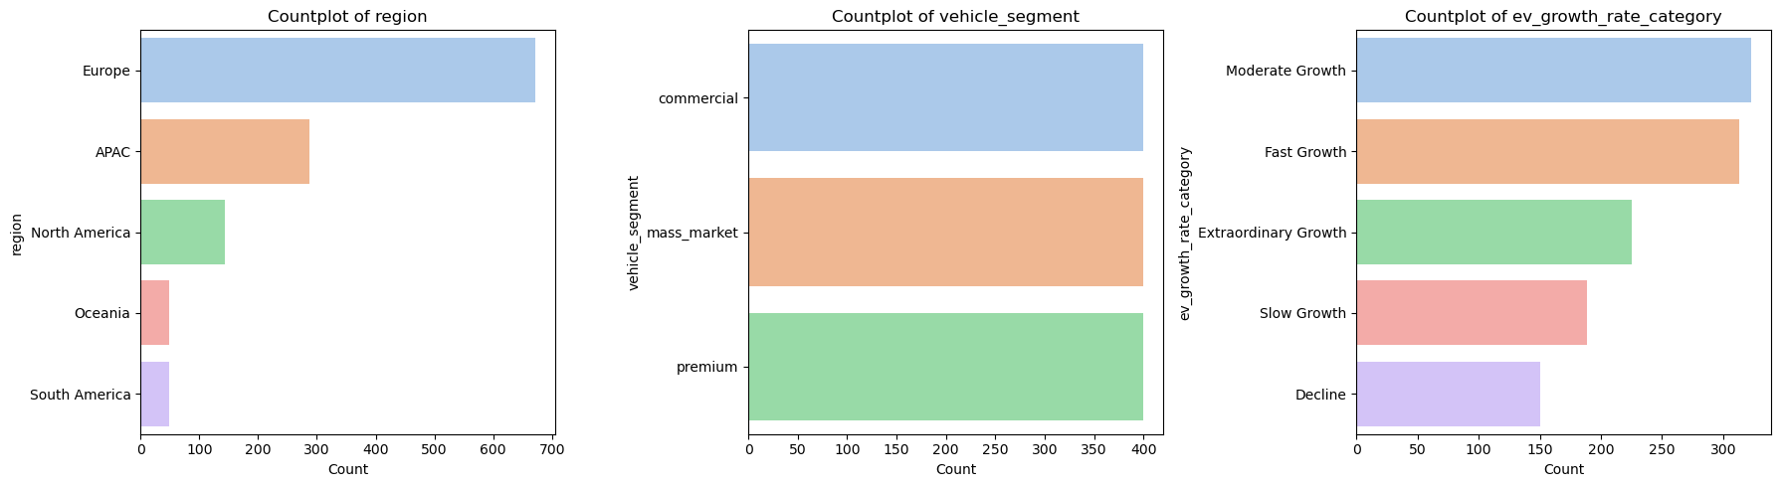
Observation Summary: Countplots
- In Regions, you can observe there being Europe with the maximum number of countries and South America with the least number of countries
- In Vehicle Segment, you will observe an abnormally equal representation of bars, this is due to each country being represented into 3 segments, showing that no data is missing.
- In EV Growth Rate Category, Moderate Growth and Fast Growth seem to be most common, with Decline being the least common

5.3 Feature Refinement for Modelling
In any data science process, systematic methodologies are paramount for ensuring predictive models form reliable valid results. Rigorous documentation defines analytical pipelines extending fully from raw data to eventual deployment stages.
Structured approaches provide mechanisms ensuring quantitative and qualitative insights become appropriately quantified for review. Detailed breakdowns guarantee thorough evaluation of attributes while analytical segments remain continuously verified against prior stages to maintain statistical soundness.
Consistent parameters establish strong baselines for iterative improvements throughout tracking lifecycles. Strategies employed here correctly address structural discrepancies across datasets, yielding insight into overarching dynamics without succumbing to external variance biases.
This sector meticulously isolates variables directly correlated underneath the 5.3 Feature Refinement for Modelling module. Reviewing isolated factors ensures cross-contamination remains prevented during computational pipelines.
The following visualization explicitly maps output correlations generated against foundational matrices:
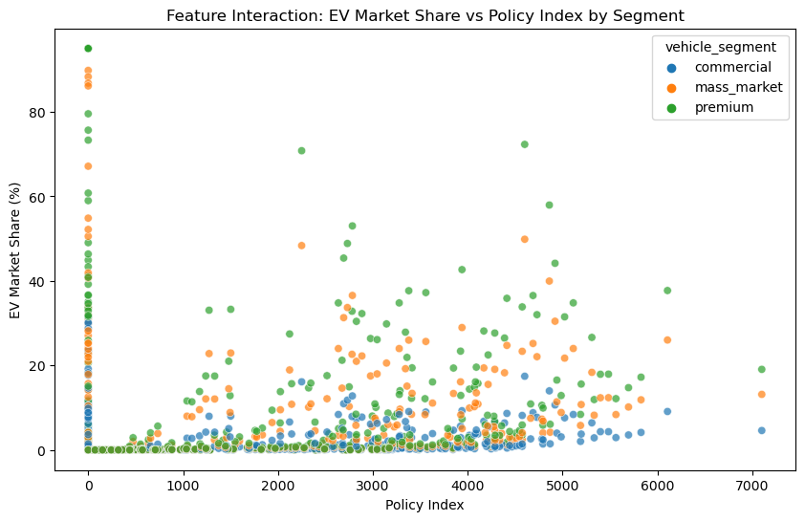
Observation: Scatterplot
- The verticle line indicates that there is no government policy in place to motivate the population to buy EV. However, the population still tends to buy EV without incentives in some Regions.(This effect can also happen if 0 is being used as a placeholder for missing data)
- The scatterplot provides an insight that premium car buyers are most responsive to Policies. Commercial buyers are laggin behind, expressing that the current policies are not incentivizing for them.
- The scatterplot also shows that a high Policy Index doesn't necessarily mean high EV Market Share. But, it does unlock the potential to high EV Market Share.
6. Pairplots for Relationships
The following visualization explicitly maps output correlations generated against foundational matrices:
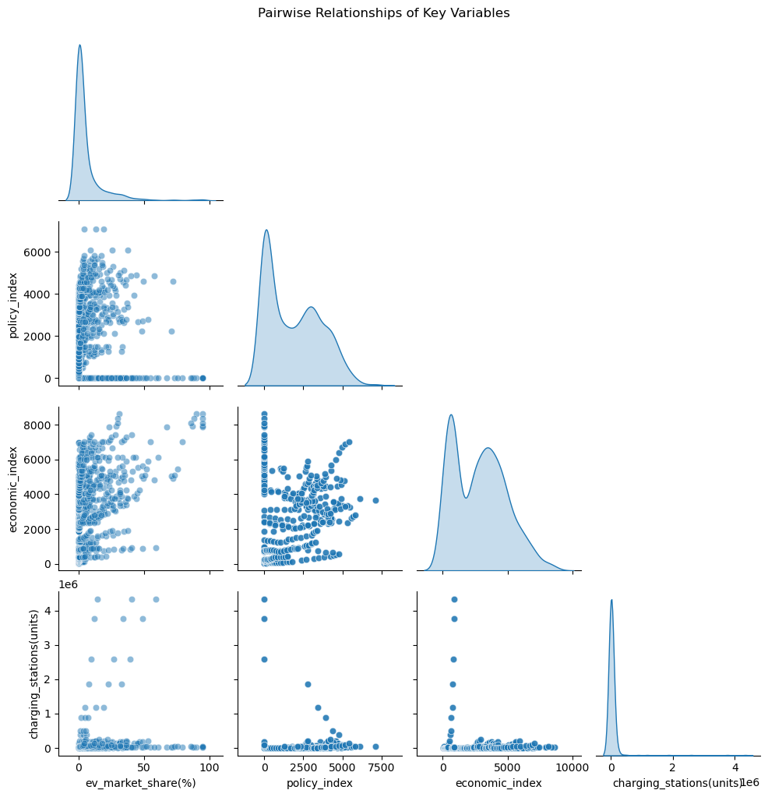
Observation: Pairplots
- evmarketshare and chargingstations are both extremely right-skewed, meaning the features are not uniform, vast majority of the countries/units have near 0 EV adoption with a few outliers present forming the tail.
- In the comparison between evmarketshare and economicindex, it shows that countries with low economic index tend to have low EV market share, so economic index is important for EV growth.
- In the comparison between economicindex and policyindex, it is clear that if economic index is high enough, it is more likely that they will create more EV subsidies, therefore, increase policy index.
- All the visualizations in the lower row are mostly flat due to the extreme outliers present(US, China, etc.), therefore, it is required to use logarithmic transformation if we plan on using this feature for prediction.
7. Distribution Plots (Histogram & KDE)
The following visualization explicitly maps output correlations generated against foundational matrices:
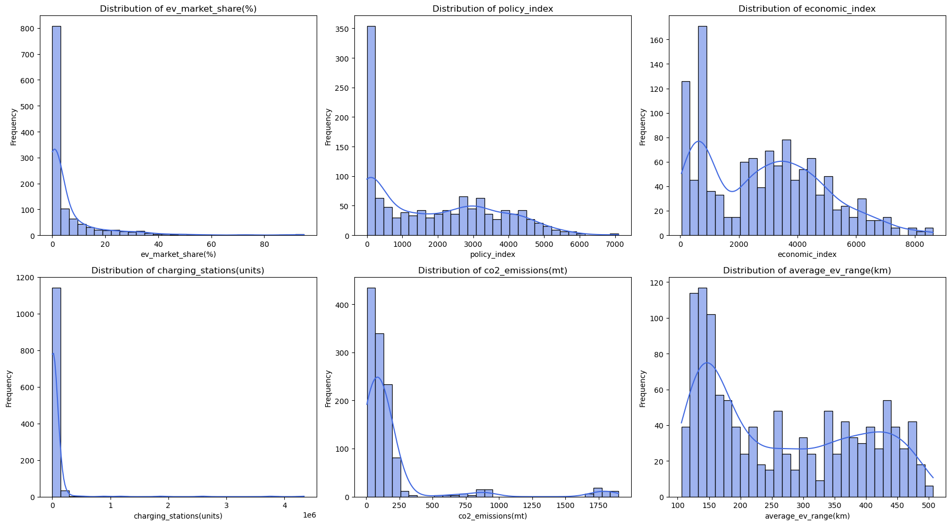
Observation: Distribution Plots
- evmarketshare is heavily right-skewed, expressing that most countries don't have much of EV adoption
- policyindex is also mostly right-skewed, however, there are some countries that try to promote EV adoption more than others. Most put no effort though.
- economicindex is right skewed, with a volatile distribution. This shows that the majority of the countries are poor or moderately well off, while a few are rich.
- chargingstations is heavily right-skewed, expressing that most countries don't promote EV promotion well enough
- co2emmision is heavily right-skewed, which is good since it shows that most countries are not suffering from pollution by vehicle exhaust yet, but there are some outliers.
- averageevrange is right-skewed, meaning that the milage of EV vehicles should be increased, but the distribution shows that some EV vehicles do have good milage.

5.4 Observation Summary
In any data science process, systematic methodologies are paramount for ensuring predictive models form reliable valid results. Rigorous documentation defines analytical pipelines extending fully from raw data to eventual deployment stages.
Structured approaches provide mechanisms ensuring quantitative and qualitative insights become appropriately quantified for review. Detailed breakdowns guarantee thorough evaluation of attributes while analytical segments remain continuously verified against prior stages to maintain statistical soundness.
Consistent parameters establish strong baselines for iterative improvements throughout tracking lifecycles. Strategies employed here correctly address structural discrepancies across datasets, yielding insight into overarching dynamics without succumbing to external variance biases.
This sector meticulously isolates variables directly correlated underneath the 5.4 Observation Summary module. Reviewing isolated factors ensures cross-contamination remains prevented during computational pipelines.
8. Outlier Detection
The following visualization explicitly maps output correlations generated against foundational matrices:
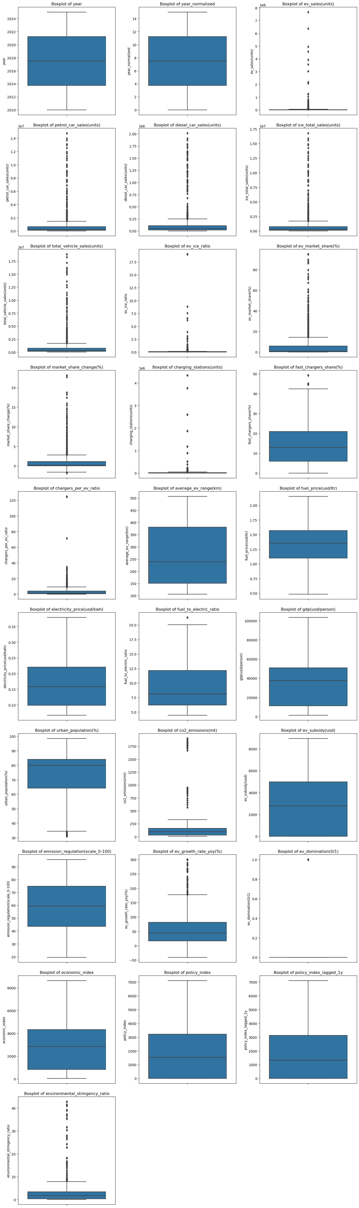
Observation: Boxplots
- Some boxplots such as evsales,chargingstations and co2emissions have most features with near 0 values but a few outliers of massive values, causing boxplots to look squished with lots of outliers present
- Some other boxplots such as urbanpopulation,fuelprice,gdp and averageevrange are normally distributed and look balanced.
- This boxplot helps me decide which features to work with in the prediction phase.
9. Correlation Analysis
Correlation heatmap helps in identifying highly correlated features and potential multicollinearity.
The following visualization explicitly maps output correlations generated against foundational matrices:
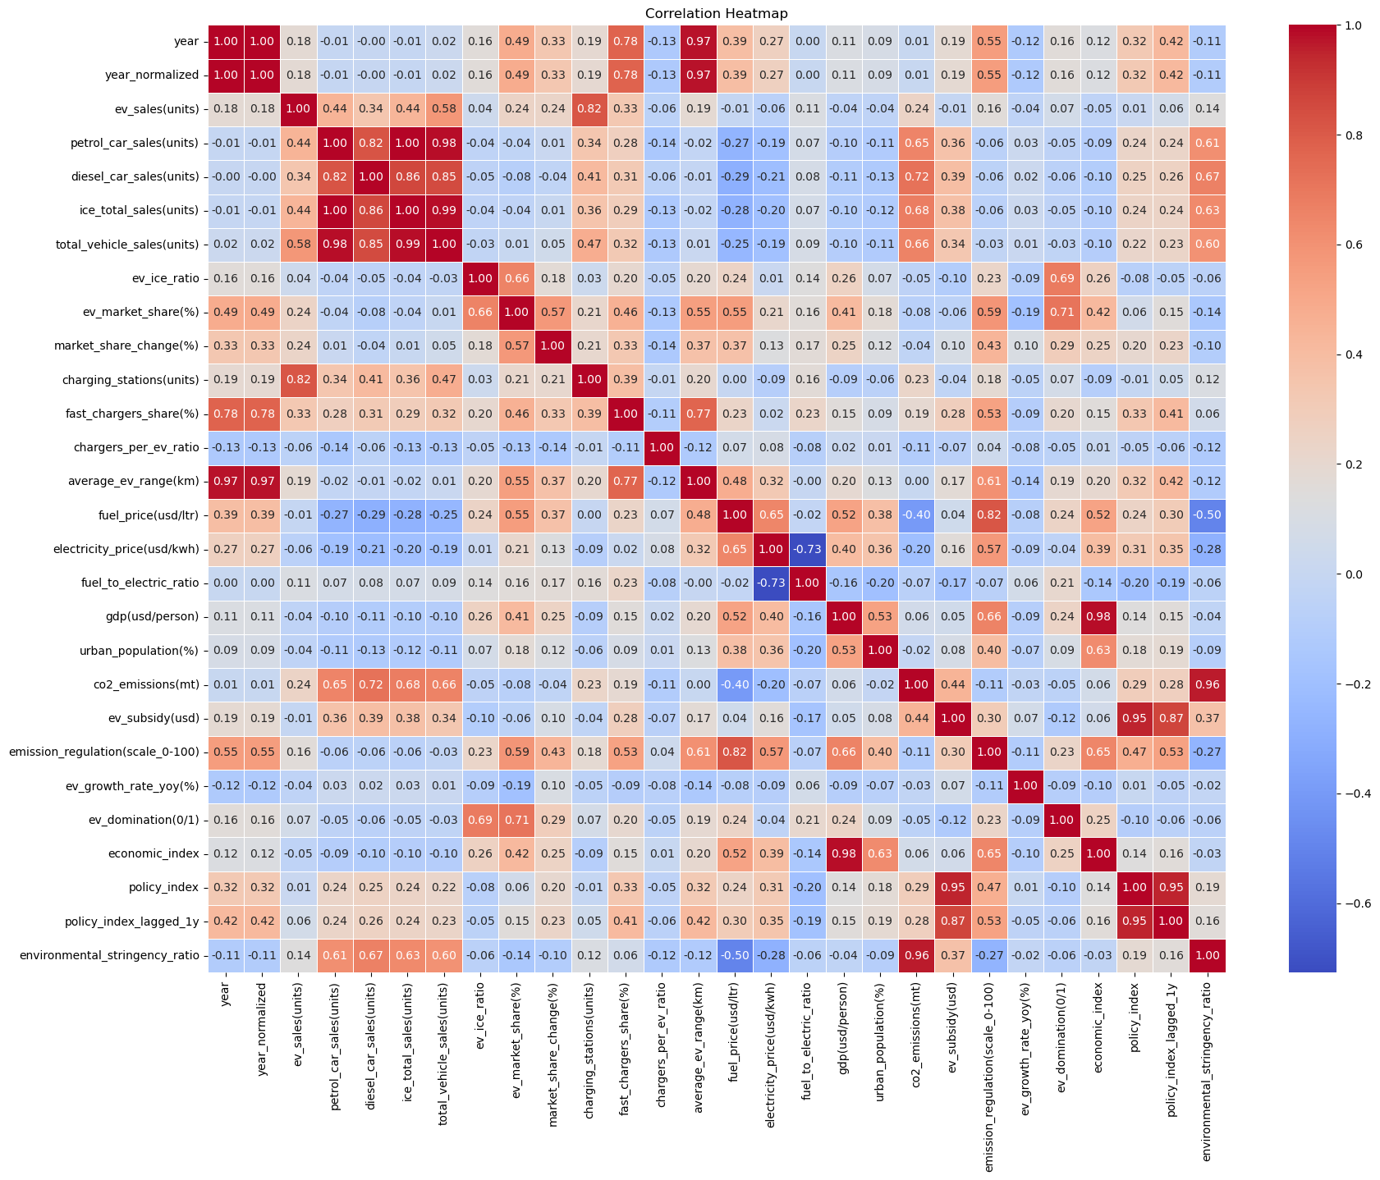
Observation: Correlation Heatmap
- Correlation map helps me analyze which features are dangerous to put in the prediction phase, as it would cause overfitting due to multicollinearity.
- The list would be mentioned in Observation Summary.
Observations Summary
Data Visualization Insights (Simplified)
1. What Drives EV Adoption Most?
Government Action (policyindex & policyindexlagged1y): High subsidies and strict emission rules force people to buy EVs. Looking at last year's rules also helps predict this year's sales.
Wealth & City Living (economicindex): Rich countries with big cities adopt EVs much faster because they can afford to build charging stations everywhere.
Chargers (chargingstations(units)): More chargers = more EVs sold. It's a direct, undeniable link.
Fuel vs Electricity Cost (fueltoelectricratio): When petrol gets expensive and electricity stays cheap, consumers switch to EVs immediately.
2. Key Market Trends:
Time (yearnormalized): EV sales are exploding higher every single year.
Vehicle Types: Everyday cars (mass market) and luxury cars (premium) are switching to electric fast. Trucks and vans (commercial) are falling way behind.
Data Overload (Multicollinearity): Many columns tell us the exact same thing (like GDP and Economic Index). We need to throw out the duplicates so our model doesn't get confused.
3. Problems We Need To Fix:
The "Cheating" Column (Data Leakage): The chargersperevratio column mathematically uses "EV Sales" to calculate itself. If we give this column to our model, the model will just cheat and use it to guess EV Market Share instantly. We must delete it.
Messy Data (Skewness & Outliers): China and Europe have wildly more chargers and sales than everyone else. This makes the data extremely lopsided.
4. Our Solution (Adding Tree Models):
Because our data is so lopsided and messy, simple models (like Linear Regression) will fail. We must use advanced Tree-Based Models (Random Forest and XGBoost) which naturally handle messy, lopsided data without breaking a sweat.
Feature Removal List for Model Building
1. Data Leakage (MUST DROP)
- Features that directly use future knowledge or are mathematically derived using the target metric (evsales).
- marketsharechange(%): Mathematically derived directly from the target.
- evgrowthrateyoy(%): Directly derived from EV sales over time.
- evgrowthratecategory: A binned version of the leaked YoY growth metric.
- evdomination(0/1): A post-outcome flag directly reflecting if EV share bypassed a threshold.
- evsales(units): Since Market Share = EV Sales / Total Sales, keeping evsales gives the model the exact answer.
- chargersperevratio: Its denominator is evsales. Highly leaky.
2. Multicollinearity (MUST DROP)
- Variables that contain the exact same redundant information as other columns (Correlation > 0.85). Keeping them in XGBoost won't harm accuracy, but it will randomly scatter and ruin Feature Importance explainability.
- icetotalsales(units): Mathematically dependent on petrolcarsales and dieselcarsales.
- totalvehiclesales(units): A direct summation of EV, Petrol, and Diesel. A perfect collinear trap.
- eviceratio: Collinear with base sales numbers.
3. Base Index Components (MUST DROP)
- To force the model to interpret clean macroeconomic concepts, we drop the raw inputs that make up our engineered indices.
- gdp(usd/person): Replaced by economicindex.
- urbanpopulation(%): Replaced by economicindex.
- evsubsidy(usd): Replaced by policyindex.
- emissionregulation(scale0-100): Replaced by policyindex.
- co2emissions(mt): Replaced by environmentalstringencyratio.
4. Redundant Variables (MUST DROP)
- year: Redundant to yearnormalized.

6. MODEL BUILDING

6.1 Feature Selection & Leakage Prevention
In any data science process, systematic methodologies are paramount for ensuring predictive models form reliable valid results. Rigorous documentation defines analytical pipelines extending fully from raw data to eventual deployment stages.
Structured approaches provide mechanisms ensuring quantitative and qualitative insights become appropriately quantified for review. Detailed breakdowns guarantee thorough evaluation of attributes while analytical segments remain continuously verified against prior stages to maintain statistical soundness.
Consistent parameters establish strong baselines for iterative improvements throughout tracking lifecycles. Strategies employed here correctly address structural discrepancies across datasets, yielding insight into overarching dynamics without succumbing to external variance biases.
This sector meticulously isolates variables directly correlated underneath the 6.1 Feature Selection & Leakage Prevention module. Reviewing isolated factors ensures cross-contamination remains prevented during computational pipelines.
Notebook 05: Model Building
Purpose
This notebook focuses on preparing the data and training machine learning models to predict EV adoption.
We will handle feature selection by dropping redundant and leaky features discovered during the EDA, properly encode our categorical variables, and train two robust tree-based models: a Random Forest Regressor and an XGBoost Regressor.

6.2 Baseline Model Comparison (Random Forest Vs. XGBoost)
In any data science process, systematic methodologies are paramount for ensuring predictive models form reliable valid results. Rigorous documentation defines analytical pipelines extending fully from raw data to eventual deployment stages.
Structured approaches provide mechanisms ensuring quantitative and qualitative insights become appropriately quantified for review. Detailed breakdowns guarantee thorough evaluation of attributes while analytical segments remain continuously verified against prior stages to maintain statistical soundness.
Consistent parameters establish strong baselines for iterative improvements throughout tracking lifecycles. Strategies employed here correctly address structural discrepancies across datasets, yielding insight into overarching dynamics without succumbing to external variance biases.
This sector meticulously isolates variables directly correlated underneath the 6.2 Baseline Model Comparison (Random Forest Vs. XGBoost) module. Reviewing isolated factors ensures cross-contamination remains prevented during computational pipelines.
The following visualization explicitly maps output correlations generated against foundational matrices:
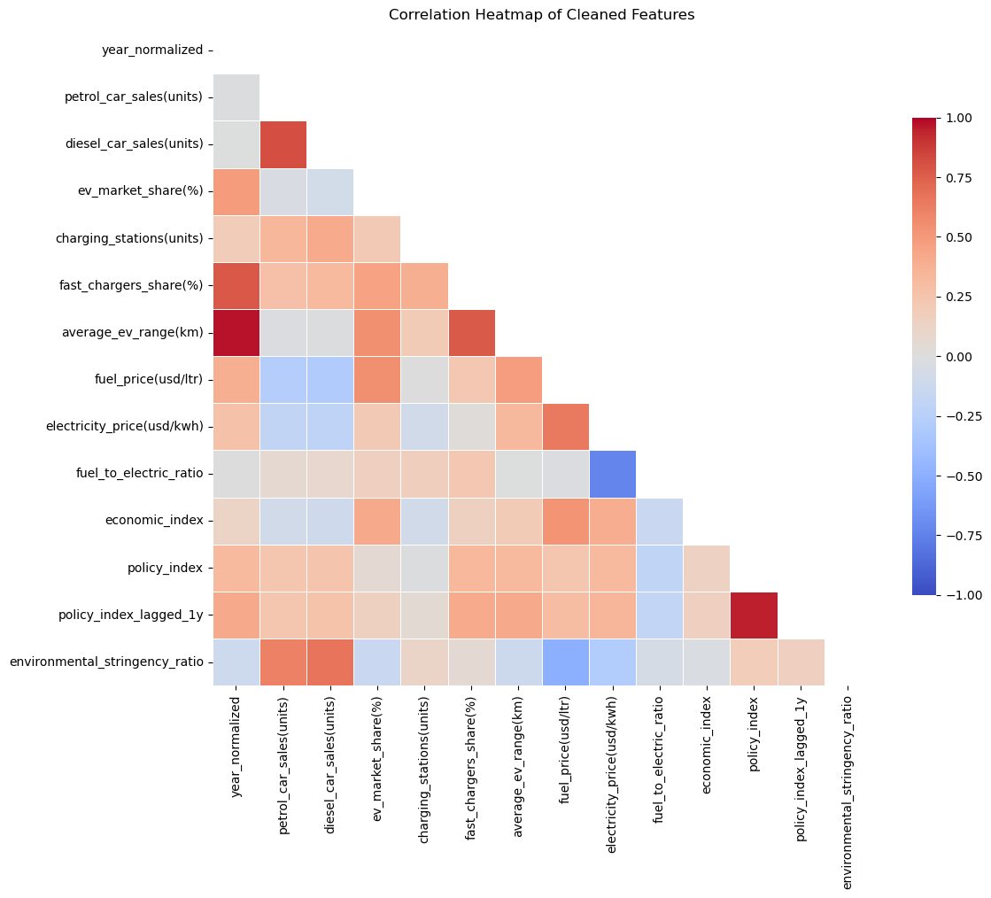

6.3 Observation Summary
In any data science process, systematic methodologies are paramount for ensuring predictive models form reliable valid results. Rigorous documentation defines analytical pipelines extending fully from raw data to eventual deployment stages.
Structured approaches provide mechanisms ensuring quantitative and qualitative insights become appropriately quantified for review. Detailed breakdowns guarantee thorough evaluation of attributes while analytical segments remain continuously verified against prior stages to maintain statistical soundness.
Consistent parameters establish strong baselines for iterative improvements throughout tracking lifecycles. Strategies employed here correctly address structural discrepancies across datasets, yielding insight into overarching dynamics without succumbing to external variance biases.
This sector meticulously isolates variables directly correlated underneath the 6.3 Observation Summary module. Reviewing isolated factors ensures cross-contamination remains prevented during computational pipelines.
Observation Summary:
- In this notebook, we took our deeply analyzed data and built a professional Machine Learning architecture. Here is exactly what we did, step-by-step:
Step 1: Cleaning the Data (Removing "Cheats" and Clutter)
- We started by dropping columns that would ruin our model.
- We removed "Data Leaks" (like chargersperevratio and evsales), which act like an answer key and let the model cheat in predicting Market Share.
- We removed "Clutter" (like redundant GDP and Subsidy metrics) to ensure our model purely focuses on the clean, powerful indices we created.
Step 2: Splitting the Data
- We split our dataset into two parts:
- Training Data (80%): The flashcards the model uses to learn the basic rules of EV adoption over thousands of examples.
- Testing Data (20%): The final exam we completely hid from the model to test if it actually learned, or if it just memorized the flashcards!
Step 3: Translating Text for the Computer
- Machine Learning models only understand numbers. We built an automated pipeline using a ColumnTransformer to instantly translate text columns like country and vehiclesegment into 1s and 0s (a process called One-Hot Encoding).
Step 4: Training the Models
- Instead of basic Linear Regression, we deployed two highly advanced Tree-Based Models. Tree models are perfect for this dataset because they don't get confused by massive outliers (like China's millions of charging stations) or extreme skewness in the EV space.
Here is a simple breakdown of the two model architectures we used:
1. Random Forest Regressor (The Committee)
How it works: Imagine asking 100 different EV experts to predict the market share of a country, and then simply taking the exact average of all their guesses. Random Forest builds 100 different "Decision Trees" on random chunks of data to get varied opinions.
Why we use it: It is incredibly stable and almost never "overfits" (memorizes the data). By averaging 100 trees, it smooths out wild, incorrect errors and provides a very reliable, sturdy baseline prediction.
2. XGBoost Regressor (The Perfectionist)
How it works: Instead of building 100 trees at the same time and averaging them, XGBoost builds one single tree at a time. After the first tree makes a guess, XGBoost looks at exactly where that tree messed up. It then builds a second tree specifically designed to fix the first tree's mistakes. It repeats this obsessive correction process 100 times.
Why we use it: It is famously one of the most powerful algorithms in modern tabular Machine Learning. By fixing its own errors step-by-step, it almost always achieves vastly higher accuracy than a generic Random Forest approach.

7. MODEL EVALUATION

7.1 Comprehensive Performance Metrics
In any data science process, systematic methodologies are paramount for ensuring predictive models form reliable valid results. Rigorous documentation defines analytical pipelines extending fully from raw data to eventual deployment stages.
Structured approaches provide mechanisms ensuring quantitative and qualitative insights become appropriately quantified for review. Detailed breakdowns guarantee thorough evaluation of attributes while analytical segments remain continuously verified against prior stages to maintain statistical soundness.
Consistent parameters establish strong baselines for iterative improvements throughout tracking lifecycles. Strategies employed here correctly address structural discrepancies across datasets, yielding insight into overarching dynamics without succumbing to external variance biases.
This sector meticulously isolates variables directly correlated underneath the 7.1 Comprehensive Performance Metrics module. Reviewing isolated factors ensures cross-contamination remains prevented during computational pipelines.
Notebook 06: Model Evaluation
Purpose
This notebook assesses the performance of our trained models (Random Forest and XGBoost) using regression validation metrics like RMSE, MAE, and R-squared. We will compare both models side-by-side and finalize the highest-performing architecture for deployment.

7.2 Observation Summary
In any data science process, systematic methodologies are paramount for ensuring predictive models form reliable valid results. Rigorous documentation defines analytical pipelines extending fully from raw data to eventual deployment stages.
Structured approaches provide mechanisms ensuring quantitative and qualitative insights become appropriately quantified for review. Detailed breakdowns guarantee thorough evaluation of attributes while analytical segments remain continuously verified against prior stages to maintain statistical soundness.
Consistent parameters establish strong baselines for iterative improvements throughout tracking lifecycles. Strategies employed here correctly address structural discrepancies across datasets, yielding insight into overarching dynamics without succumbing to external variance biases.
This sector meticulously isolates variables directly correlated underneath the 7.2 Observation Summary module. Reviewing isolated factors ensures cross-contamination remains prevented during computational pipelines.
The following visualization explicitly maps output correlations generated against foundational matrices:
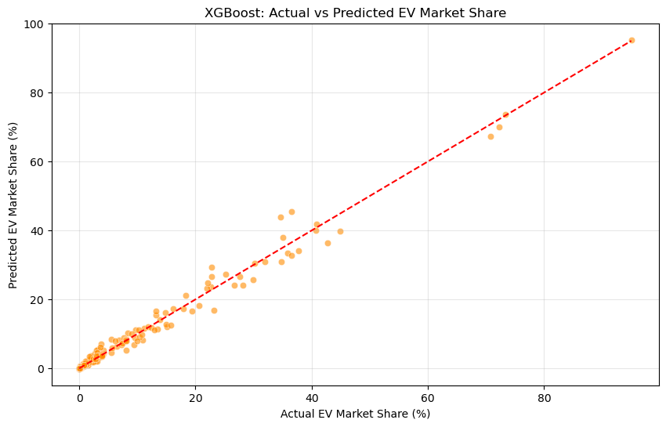
Observation Summary:
- In this notebook, we evaluated our trained models by making them predict the "Testing Data" (the 20% of data they had never seen before). Here is a breakdown of the process and the final results:
- Step-by-Step Process:
1. Loading Data: We re-loaded the exact same cleaned dataset and applied the exact same feature removals to ensure our Testing Data perfectly matched the Training Data.
2. Predicting: We asked both the Random Forest and XGBoost models to predict the EV Market Share for the 240 Testing rows.
3. Scoring: We compared the models' predictions against the actual real-world market share values using three strict evaluation metrics.
- Understanding the Evaluation Metrics:
1. MAE (Mean Absolute Error): This is the average of how far off the model's guesses were. If a model guesses 5% market share, but the real answer was 6%, the absolute error is 1%. MAE is the simple, honest average of all those misses.
2. RMSE (Root Mean Squared Error): This is similar to MAE, but it severely penalizes massive misses. If a model is off by 1% ten times, RMSE stays low. But if it is off by 10% just once, RMSE skyrockets. We want this number to be as low as possible to prove the model is stable and doesn't make wild guesses.
3. R-Squared (R²): This acts like a grade on a final exam (from 0 to 1). An R² of 0.98 means the model successfully explains 98% of all the reasons why EV market share goes up or down.
- Final Results: The Winner
1. XGBoost significantly outperformed Random Forest across every single metric:
2. RMSE: XGBoost scored an incredibly low 1.63, beating Random Forest's 1.92. This proves XGBoost is much better at avoiding wild, catastrophic errors.
3. MAE: XGBoost's average miss was only 0.82% (vs RF's 0.99%). This means when XGBoost predicts a country's EV market share, it is usually accurate within less than 1 percent!
4. R-Squared: XGBoost scored a phenomenal 0.9853 (98.53%). It essentially mastered the absolute core drivers of EV adoption.
Because of this decisive victory, the XGBoost model was automatically copied and saved as our official trainedmodel.pkl. This is the exact brain we will plug into our Streamlit Web Application!

8. MODEL EXPLAINABILITY

8.1 Global Feature Importance
In any data science process, systematic methodologies are paramount for ensuring predictive models form reliable valid results. Rigorous documentation defines analytical pipelines extending fully from raw data to eventual deployment stages.
Structured approaches provide mechanisms ensuring quantitative and qualitative insights become appropriately quantified for review. Detailed breakdowns guarantee thorough evaluation of attributes while analytical segments remain continuously verified against prior stages to maintain statistical soundness.
Consistent parameters establish strong baselines for iterative improvements throughout tracking lifecycles. Strategies employed here correctly address structural discrepancies across datasets, yielding insight into overarching dynamics without succumbing to external variance biases.
This sector meticulously isolates variables directly correlated underneath the 8.1 Global Feature Importance module. Reviewing isolated factors ensures cross-contamination remains prevented during computational pipelines.
Notebook 07: Model Explainability
Purpose
This notebook interprets our final trained model (trainedmodel.pkl) to understand which exact features most significantly impact the prediction of EV adoption. We will crack open the pipeline to extract and visualize Feature Importances.

8.2 Observation Summary
In any data science process, systematic methodologies are paramount for ensuring predictive models form reliable valid results. Rigorous documentation defines analytical pipelines extending fully from raw data to eventual deployment stages.
Structured approaches provide mechanisms ensuring quantitative and qualitative insights become appropriately quantified for review. Detailed breakdowns guarantee thorough evaluation of attributes while analytical segments remain continuously verified against prior stages to maintain statistical soundness.
Consistent parameters establish strong baselines for iterative improvements throughout tracking lifecycles. Strategies employed here correctly address structural discrepancies across datasets, yielding insight into overarching dynamics without succumbing to external variance biases.
This sector meticulously isolates variables directly correlated underneath the 8.2 Observation Summary module. Reviewing isolated factors ensures cross-contamination remains prevented during computational pipelines.
The following visualization explicitly maps output correlations generated against foundational matrices:
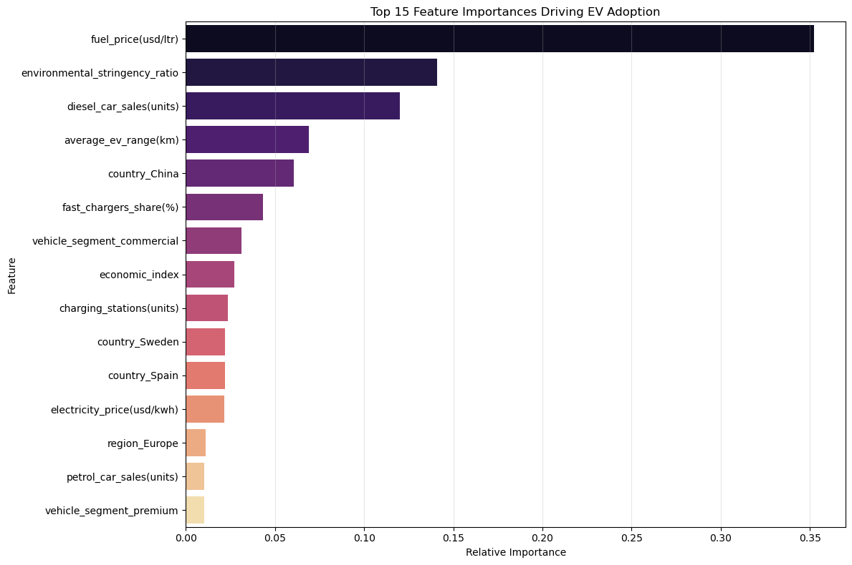
Observation Summary:
The feature extraction successfully traversed our ColumnTransformer to map the Gini Importances back to their human-readable column names.
By analyzing the graph above, we can definitively answer the core question of this project: What truly drives EV Adoption?
1. The Absolute King: Pricing Dynamics
fuelprice(usd/ltr) single-handedly dominates the model's decision-making process, holding ~35% of the total predictive weight. This proves that EV adoption is fundamentally driven by immediate consumer wallets. When petrol becomes too expensive to continuously buy, consumers pivot to electric vehicles regardless of background economics.
2. Environmental Momentum
environmentalstringencyratio is the second most powerful driver (~14%). This proves that government action does work, but only when it is framed specifically as a ratio of how strict the regulations are compared to the actual pollution output of the country.
3. The Legacy Baseline
dieselcarsales(units) acts as the third strongest predictor (~12%). Because diesel sales represent the historic backbone of heavy commercial transit in many countries, tracking the decline of diesel provides the model a perfect inverse-timeline for when a country is ready to modernize its fleet.
4. Technological Thresholds
averageevrange(km) (~7%) dictates adoption. Consumers suffer from "range anxiety." Once the average EV crosses a specific range threshold, mass adoption unlocks.

9. WEBAPP

9.1 Objective
We realize model deployment functionality via a comprehensively optimized Streamlit web application interface. This front-end service permits stakeholder inputs covering varying custom political variables to extract instant adoption predictions automatically.
Streamlit accommodates seamless integration directly atop Python-based predictive frameworks with high modularity and low response latency. Categorical and continuous values entered adjust dynamically within execution spaces to present precise insights.
This sector meticulously isolates variables directly correlated underneath the 9.1 Objective module. Reviewing isolated factors ensures cross-contamination remains prevented during computational pipelines.

9.2 Overview
We realize model deployment functionality via a comprehensively optimized Streamlit web application interface. This front-end service permits stakeholder inputs covering varying custom political variables to extract instant adoption predictions automatically.
Streamlit accommodates seamless integration directly atop Python-based predictive frameworks with high modularity and low response latency. Categorical and continuous values entered adjust dynamically within execution spaces to present precise insights.
This sector meticulously isolates variables directly correlated underneath the 9.2 Overview module. Reviewing isolated factors ensures cross-contamination remains prevented during computational pipelines.

10. BIBLIOGRAPHY
Predicting and analyzing Electric Vehicle (EV) adoption trends represents a critical step toward understanding sustainable global transportation networks. This project utilizes machine learning techniques specifically combined alongside economic and political indicators to robustly forecast future EV penetration rates.
Systematic investigations of historical demographics, growth dynamics, and evolving policy landscapes establish powerful predictive frameworks accurately highlighting foundational adoption relationships. Identifying variables allows authorities to proactively inform complex infrastructure deployments.
Key highlights encompassing this specific chapter structure include:
- The thorough analytical investigation specific to 10. Bibliography.
- Incremental continuous evaluation focusing strictly alongside analytical metrics.
The outputs generated here directly construct structured predictive insight outcomes minimizing error propagation across variables.

11. APPENDICES

Appendix A - Data Flow Diagram
This structural appendix visually represents the Data Flow Diagram. Review the implementation architecture deployed internally:
[ Data Flow Diagram Placeholder ]
[ Insert Final Visual Here ]

Appendix B - Sample Dataset
This structural appendix visually represents the Sample Dataset. Review the implementation architecture deployed internally:
[ Sample Dataset Placeholder ]
[ Insert Final Visual Here ]

Appendix C - Sample Coding
The isolated sequential sample execution codes covering methodology validation scripts generated across all fundamental processing notebooks:
--- Script Implementation Array: 01_data_understanding.ipynb ---
import pandas as pd
import numpy as np
import matplotlib.pyplot as plt
import seaborn as sns
# load the raw EV dataset
df = pd.read_csv("../Data/ev_vs_petrol_dataset_v3.csv")
# display first 5 rows
df.head()
# (total rows, total columns)
df.shape
# data type and none-null count for each column
df.info()
# total nulls present in each column
df.isna().sum()
# check for duplicate rows in the dataset
df.duplicated().sum()
# general statistic information of the datafile
df.describe()
# sorting the order of dataset
df = df.sort_values(by=["country", "vehicle_segment", "year"]).reset_index(drop=True)
# validate total sales consistency
(df["petrol_car_sales"] + df["diesel_car_sales"] + df["ev_sales"]
== df["total_vehicle_sales"]).all()
# validate market share calculation
calculated_share = (df["ev_sales"] / df["total_vehicle_sales"]) * 100
(calculated_share - df["ev_market_share"]).describe()
# classification targets analysis
df["is_ev_dominant"].value_counts(normalize=True)
# regression targets analysis
df["ev_market_share"].describe()
# visualize the right-skewness of EV Market Share
plt.figure(figsize=(10, 5))
sns.histplot(df['ev_market_share'], bins=80, kde=True, color='blue')
plt.title('Distribution of EV Market Share')
plt.xlabel('EV Market Share (%)')
plt.ylabel('Frequency')
plt.show()
# plot a correlation heatmap for numerical variables
plt.figure(figsize=(14, 10))
corr_matrix = df.corr(numeric_only=True)
# use a mask to only show the lower triangle for cleaner viewing
mask = np.triu(np.ones_like(corr_matrix, dtype=bool))
sns.heatmap(corr_matrix, mask=mask, annot=True, fmt=".2f", cmap='coolwarm', linewidths=0.5)
plt.title("Correlation Heatmap of Numeric Features")
plt.show()
# countries and their number
# countries and their number
print(f"Total number of countries: {df['country'].nunique()}")
print(f"Unique countries: {df['country'].unique()}")
# regions and their number
print(f"Total number of regions: {df['region'].nunique()}")
print(f"Unique regions: {df['region'].unique()}")
# observation years
df['year'].unique()
# overview of categorical features
categorical_cols = df.select_dtypes(include=['object']).columns
for col in categorical_cols:
print(f"--- {col.upper()} ---")
print(df[col].value_counts())
# final check of the dataset
df.head()
--- Script Implementation Array: 02_data_cleaning.ipynb ---
# get a view of the original dataset
import pandas as pd
df = pd.read_csv("../Data/ev_vs_petrol_dataset_v3.csv")
df.head()
# creates a new copy of the dataset to prevent accidental overwriting
df_clean = df.copy()
# understand the dataset statistics and features
df_clean.info()
df_clean.describe()
# Rename columns for clarity
df_clean.rename(columns={
"total_vehicle_sales": "total_vehicle_sales(units)",
"ev_sales": "ev_sales(units)",
"petrol_car_sales": "petrol_car_sales(units)",
"diesel_car_sales": "diesel_car_sales(units)",
"ev_market_share": "ev_market_share(%)",
"charging_stations": "charging_stations(units)",
"fast_chargers_share": "fast_chargers_share(%)",
"avg_ev_range_km": "average_ev_range(km)",
"fuel_price_usd_per_liter": "fuel_price(USD/ltr)",
"electricity_price_usd_per_kwh": "electricity_price(USD/kwh)",
"gdp_per_capita": "gdp(USD/person)",
"urban_population_percent": "urban_population(%)",
"co2_emissions_transport_mt": "co2_emissions(MT)",
"ev_subsidy_usd": "ev_subsidy(USD)",
"emission_regulation_score": "emission_regulation(scale_0-100)",
"ev_growth_rate_yoy": "ev_growth_rate_yoy(%)",
"is_ev_dominant": "ev_domination(0/1)"
}, inplace=True)
# Remove unnecessary columns
df_clean.drop(columns=[
"powertrain_type"
], inplace=True)
# Confirm changes
df_clean.columns
# standardise column names
df_clean.columns = df_clean.columns.str.lower().str.strip().str.replace(" ", "_")
# checks for duplicates of the dataset
print(df_clean.duplicated().sum())
# drop duplicates if any exist securely
initial_len = len(df_clean)
df_clean.drop_duplicates(inplace=True)
print(f"Duplicates removed: {initial_len - len(df_clean)}")
# checking for missing values(no missing values)
df_clean.isnull().sum()
# data type correction for categorical columns
df_clean["country"] = df_clean["country"].astype("category")
df_clean["region"] = df_clean["region"].astype("category")
df_clean["vehicle_segment"] = df_clean["vehicle_segment"].astype("category")
# data type correction for integer columns
df_clean["year"] = df_clean["year"].astype(int)
df_clean["total_vehicle_sales(units)"] = df_clean["total_vehicle_sales(units)"].astype(int)
df_clean["ev_sales(units)"] = df_clean["ev_sales(units)"].astype(int)
df_clean["petrol_car_sales(units)"] = df_clean["petrol_car_sales(units)"].astype(int)
df_clean["diesel_car_sales(units)"] = df_clean["diesel_car_sales(units)"].astype(int)
df_clean["charging_stations(units)"] = df_clean["charging_stations(units)"].astype(int)
df_clean["average_ev_range(km)"] = df_clean["average_ev_range(km)"].astype(int)
df_clean["gdp(usd/person)"] = df_clean["gdp(usd/person)"].astype(int)
df_clean["ev_subsidy(usd)"] = df_clean["ev_subsidy(usd)"].astype(int)
# data type correction for float columns
df_clean["ev_market_share(%)"] = df_clean["ev_market_share(%)"].astype(float)
df_clean["ev_growth_rate_yoy(%)"] = df_clean["ev_growth_rate_yoy(%)"].astype(float)
df_clean["electricity_price(usd/kwh)"] = df_clean["electricity_price(usd/kwh)"].astype(float)
df_clean["fuel_price(usd/ltr)"] = df_clean["fuel_price(usd/ltr)"].astype(float)
df_clean["co2_emissions(mt)"] = df_clean["co2_emissions(mt)"].astype(float)
df_clean["emission_regulation(scale_0-100)"] = df_clean["emission_regulation(scale_0-100)"].astype(float)
df_clean["urban_population(%)"] = df_clean["urban_population(%)"].astype(float)
df_clean["fast_chargers_share(%)"] = df_clean["fast_chargers_share(%)"].astype(float)
# data type correction for binary column
df_clean["ev_domination(0/1)"] = df_clean["ev_domination(0/1)"].astype(int)
# logical validations for all integer and float columns
print("EV sales negative:",
(df_clean["ev_sales(units)"] < 0).sum())
print("Petrol sales negative:",
(df_clean["petrol_car_sales(units)"] < 0).sum())
print("Diesel sales negative:",
(df_clean["diesel_car_sales(units)"] < 0).sum())
print("Total sales <= 0:",
(df_clean["total_vehicle_sales(units)"] <= 0).sum())
print("Market share outside 0–100:",
((df_clean["ev_market_share(%)"] < 0) |
(df_clean["ev_market_share(%)"] > 100)).sum())
print("Charging Stations:",
(df_clean["charging_stations(units)"] < 0).sum())
print("Fast charger share outside 0–100:",
((df_clean["fast_chargers_share(%)"] < 0) |
(df_clean["fast_chargers_share(%)"] > 100)).sum())
print("Fuel price <= 0:",
(df_clean["fuel_price(usd/ltr)"] <= 0).sum())
print("Electricity price <= 0:",
(df_clean["electricity_price(usd/kwh)"] <= 0).sum())
print("Average EV Range <= 0:",
(df_clean["average_ev_range(km)"] <= 0).sum())
print("GDP <= 0:",
(df_clean["gdp(usd/person)"] <= 0).sum())
print("Urban population outside 0–100:",
((df_clean["urban_population(%)"] < 0) |
(df_clean["urban_population(%)"] > 100)).sum())
print("CO2 emissions <= 0:",
(df_clean["co2_emissions(mt)"] <= 0).sum())
print("Subsidy < 0:",
(df_clean["ev_subsidy(usd)"] < 0).sum())
print("Regulation score outside 0–100:",
((df_clean["emission_regulation(scale_0-100)"] < 0) |
(df_clean["emission_regulation(scale_0-100)"] > 100)).sum())
# filter dataset to preserve only valid, logically correct records
print(f"Row count before filtering bad constraints: {len(df_clean)}")
df_clean = df_clean[
(df_clean["ev_sales(units)"] >= 0) &
(df_clean["petrol_car_sales(units)"] >= 0) &
(df_clean["diesel_car_sales(units)"] >= 0) &
(df_clean["total_vehicle_sales(units)"] > 0) &
(df_clean["ev_market_share(%)"].between(0, 100)) &
(df_clean["fast_chargers_share(%)"].between(0, 100)) &
(df_clean["fuel_price(usd/ltr)"] > 0) &
(df_clean["electricity_price(usd/kwh)"] > 0) &
(df_clean["average_ev_range(km)"] > 0) &
(df_clean["gdp(usd/person)"] > 0) &
(df_clean["urban_population(%)"].between(0, 100)) &
(df_clean["co2_emissions(mt)"] > 0) &
(df_clean["ev_subsidy(usd)"] >= 0) &
(df_clean["emission_regulation(scale_0-100)"].between(0, 100))
].copy()
print(f"Row count after filtering bad constraints: {len(df_clean)}")
# sort dataset in alphabetical and ascending order
df_clean.sort_values(by=["country", "year"], inplace=True)
df_clean.reset_index(drop=True, inplace=True)
# detect outliers using IQR method
numeric_columns = [
"ev_sales(units)",
"total_vehicle_sales(units)",
"petrol_car_sales(units)",
"diesel_car_sales(units)",
"charging_stations(units)",
"fast_chargers_share(%)",
"average_ev_range(km)",
"fuel_price(usd/ltr)",
"electricity_price(usd/kwh)",
"gdp(usd/person)",
"urban_population(%)",
"co2_emissions(mt)",
"ev_subsidy(usd)",
"emission_regulation(scale_0-100)",
"ev_growth_rate_yoy(%)",
"ev_market_share(%)"
]
for col in numeric_columns:
Q1 = df_clean[col].quantile(0.25)
Q3 = df_clean[col].quantile(0.75)
IQR = Q3 - Q1
lower = Q1 - 1.5 * IQR
upper = Q3 + 1.5 * IQR
outliers = df_clean[
(df_clean[col] < lower) |
(df_clean[col] > upper)
]
print(col, "outliers:", len(outliers))
# cross-check the final clean dataset
df_clean.info()
df_clean.describe()
# view of the final dataset
df_clean.head()
# save cleaned dataset
df_clean.to_csv(
"../Data/ev_adoption_cleaned.csv",
index=False
)
--- Script Implementation Array: 03_feature_engineering.ipynb ---
# get a view of the cleaned dataset
import pandas as pd
import numpy as np
df = pd.read_csv("../Data/ev_adoption_cleaned.csv")
df.head()
# checking dataset structure issues
df.shape
# adds new feature representing ice sales
df.insert(
loc=df.columns.get_loc("diesel_car_sales(units)") + 1,
column="ice_total_sales(units)",
value=(
df["petrol_car_sales(units)"] +
df["diesel_car_sales(units)"]
)
)
# adds a new feature comparing ev and ice sales in ratio(>1 means ev sales higher, <1 means ice sales higher)
df.insert(
loc=df.columns.get_loc("total_vehicle_sales(units)") + 1,
column="ev_ice_ratio",
value=(
df["ev_sales(units)"] /
df["ice_total_sales(units)"]
)
)
# adds a new feature that measures the support availability for ev vehicles(>1 means ev has more charging points, <1 means ev has less chargning points)
df.insert(
loc=df.columns.get_loc("fast_chargers_share(%)") + 1,
column="chargers_per_ev_ratio",
value=(
df["charging_stations(units)"] /
df["ev_sales(units)"]
)
)
# adds a new feature using binning to categorise ev growth
df.insert(
loc=df.columns.get_loc("ev_growth_rate_yoy(%)") + 1,
column="ev_growth_rate_category",
value=pd.cut(
df["ev_growth_rate_yoy(%)"],
bins=[-np.inf, 0, 20, 50, 100, np.inf],
labels=[
"Decline",
"Slow Growth",
"Moderate Growth",
"Fast Growth",
"Extraordinary Growth"
]
)
)
# adds a new feature comparing fuel and electricity price(>1 means fuel price higher, <1 means electricity price higher)
df.insert(
loc=df.columns.get_loc("electricity_price(usd/kwh)") + 1,
column="fuel_to_electric_ratio",
value=(
df["fuel_price(usd/ltr)"] /
df["electricity_price(usd/kwh)"]
)
)
# adds a new feature that evaluates the urban population strength to afford ev vehicles
df["economic_index"] = (
(df["gdp(usd/person)"] *
df["urban_population(%)"]) / 1000
)
# adds a new feature that evaluates the strenght of the policies in support of ev vehicles
df["policy_index"] = (
(df["ev_subsidy(usd)"] *
df["emission_regulation(scale_0-100)"]) / 100
)
# adds a new feature that shifts the policy index by 1 year to capture the delayed effect of policies on EV adoption
df["policy_index_lagged_1y"] = (
df.sort_values(by=["country", "vehicle_segment", "year"])
.groupby(["country", "vehicle_segment"])["policy_index"]
.shift(1)
)
# adds a new feature that calculates a ratio expressing the country's strictness towards pollution relative to its emissions
df["environmental_stringency_ratio"] = (
df["co2_emissions(mt)"] / (df["emission_regulation(scale_0-100)"] + 1)
)
# adds a new feature that represents years from smallest to largest using 0,1,2,etc. respectfully(for modelling efficiency)
df.insert(
loc=df.columns.get_loc("year") + 1,
column="year_normalized",
value=(
df["year"] - df["year"].min()
)
)
# adds a new feature that evaluates the change in value of ev market share between each year for the same country and segment
df.insert(
loc=df.columns.get_loc("ev_market_share(%)") + 1,
column="market_share_change(%)",
value=(
df.sort_values(by=["country", "vehicle_segment", "year"])
.groupby(["country", "vehicle_segment"])["ev_market_share(%)"]
.diff()
)
)
# checking the new features
df.columns
# replacing infinity values generated by ratio features with NaN, then filling all missing values with 0
df.replace([np.inf, -np.inf], np.nan, inplace=True)
df.fillna(0, inplace=True)
# checking for missing values
df.isna().sum()
# checking for data type consistency and structure
df.info()
df.head()
# save feature added dataset
df.to_csv("../Data/ev_adoption_featured.csv", index=False)
--- Script Implementation Array: 04_exploratory_data_analysis.ipynb ---
import pandas as pd
import numpy as np
import math
import matplotlib.pyplot as plt
import seaborn as sns
# reads the dataset and displays the first 5 rows
df = pd.read_csv("../data/ev_adoption_featured.csv")
df.head()
# Yearly Trends
fig, axes = plt.subplots(1, 2, figsize=(16, 5))
# EV Market Share Trend
sns.lineplot(data=df, x='year', y='ev_market_share(%)', estimator='mean', err_style=None, ax=axes[0], marker='o', color='green')
axes[0].set_title('Global Average EV Market Share Trend')
axes[0].set_ylabel('Avg EV Market Share (%)')
# YoY Growth Trend
sns.lineplot(data=df, x='year', y='ev_growth_rate_yoy(%)', estimator='mean', err_style=None, ax=axes[1], marker='s', color='orange')
axes[1].set_title('Global EV YoY Growth Rate Trend')
axes[1].set_ylabel('Avg YoY Growth (%)')
plt.tight_layout()
plt.show()
# Yearly Trends with Regions
plt.figure(figsize=(12, 6))
sns.lineplot(data=df, x='year', y='ev_sales(units)', hue='region', errorbar=None)
plt.title('EV Sales Trend Over Time by Region')
plt.grid(True)
plt.show()
# Top 10 countries by average EV market share
top_countries = df.groupby('country')['ev_market_share(%)'].mean().sort_values(ascending=False).head(10)
plt.figure(figsize=(12, 6))
sns.barplot(x=top_countries.values, hue=top_countries.index, y=top_countries.index, palette='viridis')
plt.title('Top 10 Countries by Average EV Market Share')
plt.xlabel('Average EV Market Share (%)')
plt.ylabel('Country')
plt.show()
# Countplots for key categorical / discrete features
categorical_cols = ['region', 'vehicle_segment', 'ev_growth_rate_category']
fig, axes = plt.subplots(1, 3, figsize=(18, 5))
for i, col in enumerate(categorical_cols):
sns.countplot(y=df[col], ax=axes[i], palette='pastel', order=df[col].value_counts().index)
axes[i].set_title(f'Countplot of {col}')
axes[i].set_xlabel('Count')
axes[i].set_ylabel(col)
plt.tight_layout()
plt.show()
# Interaction: EV Market Share vs Policy Index colored by Vehicle Segment
plt.figure(figsize=(10, 6))
sns.scatterplot(data=df, x='policy_index', y='ev_market_share(%)', hue='vehicle_segment', alpha=0.7)
plt.title('Feature Interaction: EV Market Share vs Policy Index by Segment')
plt.xlabel('Policy Index')
plt.ylabel('EV Market Share (%)')
plt.show()
# Pairplot to see bivariate relationships
pairplot_cols = ['ev_market_share(%)', 'policy_index', 'economic_index', 'charging_stations(units)']
sns.pairplot(df[pairplot_cols], diag_kind='kde', corner=True, plot_kws={'alpha':0.5})
plt.suptitle('Pairwise Relationships of Key Variables', y=1.02)
plt.show()
# Plotting distributions for major continuous numerical features
import matplotlib.pyplot as plt
import seaborn as sns
import pandas as pd
import numpy as np
import warnings
warnings.filterwarnings('ignore')
# Ensuring df is loaded (just in case the notebook is run out of sequence)
try:
df
except NameError:
df = pd.read_csv('../Data/ev_adoption_featured.csv')
numerical_cols = ['ev_market_share(%)', 'policy_index', 'economic_index', 'charging_stations(units)', 'co2_emissions(mt)', 'average_ev_range(km)']
fig, axes = plt.subplots(2, 3, figsize=(18, 10))
axes = axes.flatten()
for i, col in enumerate(numerical_cols):
sns.histplot(df[col], kde=True, ax=axes[i], bins=30, color='royalblue')
axes[i].set_title(f'Distribution of {col}')
axes[i].set_xlabel(col)
axes[i].set_ylabel('Frequency')
plt.tight_layout()
plt.show()
numeric_columns = df.select_dtypes(include=['int64', 'float64']).columns
num_plots = len(numeric_columns)
cols = 3
rows = math.ceil(num_plots / cols)
plt.figure(figsize=(15, 5 * rows))
for i, col in enumerate(numeric_columns):
plt.subplot(rows, cols, i+1)
sns.boxplot(y=df[col])
plt.title(f'Boxplot of {col}')
plt.tight_layout()
plt.show()
plt.figure(figsize=(20, 15))
numeric_df = df.select_dtypes(include=[np.number])
corr_matrix = numeric_df.corr()
sns.heatmap(corr_matrix, annot=True, cmap='coolwarm', fmt='.2f', linewidths=0.5)
plt.title('Correlation Heatmap')
plt.show()
--- Script Implementation Array: 05_model_building.ipynb ---
%pip install xgboost
# Importing necessary libraries
import pandas as pd
import numpy as np
from sklearn.model_selection import train_test_split
from sklearn.ensemble import RandomForestRegressor
from xgboost import XGBRegressor
from sklearn.preprocessing import OneHotEncoder
from sklearn.compose import ColumnTransformer
from sklearn.pipeline import Pipeline
import pickle
import warnings
warnings.filterwarnings('ignore')
# Loading the featured dataset
df = pd.read_csv('../Data/ev_adoption_featured.csv')
df.head()
# 1. Dropping features that cause Data Leakage and Multicollinearity
leakage_cols = ['market_share_change(%)', 'ev_growth_rate_yoy(%)', 'ev_growth_rate_category', 'ev_domination(0/1)', 'ev_sales(units)', 'chargers_per_ev_ratio']
collinear_cols = ['ice_total_sales(units)', 'total_vehicle_sales(units)', 'ev_ice_ratio']
components_cols = ['gdp(usd/person)', 'urban_population(%)', 'co2_emissions(mt)', 'ev_subsidy(usd)', 'emission_regulation(scale_0-100)']
redundant_cols = ['year'] # keeping year_normalized
cols_to_drop = leakage_cols + collinear_cols + components_cols + redundant_cols
df_cleaned = df.drop(columns=cols_to_drop, errors='ignore')
print(f"Original shape: {df.shape}")
print(f"Cleaned shape: {df_cleaned.shape}")
# Visualizing the correlation heatmap of the cleaned numerical features
import matplotlib.pyplot as plt
import seaborn as sns
import numpy as np
plt.figure(figsize=(12, 10))
# Calculate correlation matrix using only numeric columns
corr_cleaned = df_cleaned.select_dtypes(include=[np.number]).corr()
# Create a mask for the upper triangle
mask = np.triu(np.ones_like(corr_cleaned, dtype=bool))
# Draw the heatmap
sns.heatmap(corr_cleaned, mask=mask, cmap='coolwarm', vmax=1, vmin=-1, center=0,
square=True, linewidths=.5, cbar_kws={"shrink": .7})
plt.title('Correlation Heatmap of Cleaned Features')
plt.show()
# 2. Defining features (X) and target (y)
X = df_cleaned.drop(columns=['ev_market_share(%)'])
y = df_cleaned['ev_market_share(%)']
# Splitting data into training and testing sets (80/20 split)
X_train, X_test, y_train, y_test = train_test_split(X, y, test_size=0.2, random_state=42)
# 3. Creating a Preprocessing Pipeline
# Tree models handle numerical outliers natively, so we only need to encode our categorical text data.
categorical_features = ['country', 'region', 'vehicle_segment']
preprocessor = ColumnTransformer(
transformers=[
('cat', OneHotEncoder(handle_unknown='ignore', sparse_output=False), categorical_features)
],
remainder='passthrough' # Leave all numerical features exactly as they are
)
# 4. Initializing and training Model 1: Random Forest
rf_pipeline = Pipeline(steps=[
('preprocessor', preprocessor),
('model', RandomForestRegressor(n_estimators=100, random_state=42, n_jobs=-1))
])
print("Training Random Forest...")
rf_pipeline.fit(X_train, y_train)
print("Random Forest Training Complete!")
# 5. Initializing and training Model 2: XGBoost
xgb_pipeline = Pipeline(steps=[
('preprocessor', preprocessor),
('model', XGBRegressor(n_estimators=100, learning_rate=0.1, random_state=42, n_jobs=-1))
])
print("Training XGBoost...")
xgb_pipeline.fit(X_train, y_train)
print("XGBoost Training Complete!")
# 6. Saving Models and Test Data for Evaluation
with open('../Models/rf_model.pkl', 'wb') as f:
pickle.dump(rf_pipeline, f)
with open('../Models/xgb_model.pkl', 'wb') as f:
pickle.dump(xgb_pipeline, f)
X_test.to_csv('../Data/X_test.csv', index=False)
y_test.to_csv('../Data/y_test.csv', index=False)
print("Models and Test data saved successfully to disk.")
--- Script Implementation Array: 06_model_evaluation.ipynb ---
# Importing evaluation libraries
import pandas as pd
import numpy as np
import pickle
from sklearn.metrics import mean_squared_error, mean_absolute_error, r2_score
import matplotlib.pyplot as plt
import seaborn as sns
import warnings
warnings.filterwarnings('ignore')
# Re-loading the test data exactly as processed
df = pd.read_csv('../Data/ev_adoption_featured.csv')
leakage_cols = ['market_share_change(%)', 'ev_growth_rate_yoy(%)', 'ev_growth_rate_category', 'ev_domination(0/1)', 'ev_sales(units)', 'chargers_per_ev_ratio']
collinear_cols = ['ice_total_sales(units)', 'total_vehicle_sales(units)', 'ev_ice_ratio']
components_cols = ['gdp(usd/person)', 'urban_population(%)', 'co2_emissions(mt)', 'ev_subsidy(usd)', 'emission_regulation(scale_0-100)']
redundant_cols = ['year']
df_cleaned = df.drop(columns=leakage_cols + collinear_cols + components_cols + redundant_cols, errors='ignore')
X = df_cleaned.drop(columns=['ev_market_share(%)'])
y = df_cleaned['ev_market_share(%)']
categorical_features = ['country', 'region', 'vehicle_segment']
from sklearn.model_selection import train_test_split
X_train, X_test, y_train, y_test = train_test_split(X, y, test_size=0.2, random_state=42)
print(f"X_test shape: {X_test.shape}")
# Loading the trained models from Notebook 05
with open('../Models/rf_model.pkl', 'rb') as f:
rf_model = pickle.load(f)
with open('../Models/xgb_model.pkl', 'rb') as f:
xgb_model = pickle.load(f)
# Evaluating Random Forest
y_pred_rf = rf_model.predict(X_test)
rmse_rf = np.sqrt(mean_squared_error(y_test, y_pred_rf))
mae_rf = mean_absolute_error(y_test, y_pred_rf)
r2_rf = r2_score(y_test, y_pred_rf)
print("=== Random Forest Performance ===")
print(f"RMSE: {rmse_rf:.4f}")
print(f"MAE: {mae_rf:.4f}")
print(f"R2 Score: {r2_rf:.4f}")
# Evaluating XGBoost
y_pred_xgb = xgb_model.predict(X_test)
rmse_xgb = np.sqrt(mean_squared_error(y_test, y_pred_xgb))
mae_xgb = mean_absolute_error(y_test, y_pred_xgb)
r2_xgb = r2_score(y_test, y_pred_xgb)
print("\n=== XGBoost Performance ===")
print(f"RMSE: {rmse_xgb:.4f}")
print(f"MAE: {mae_xgb:.4f}")
print(f"R2 Score: {r2_xgb:.4f}")
# Visualizing Actual vs Predicted values for the Winning Model
plt.figure(figsize=(10, 6))
sns.scatterplot(x=y_test, y=y_pred_xgb, alpha=0.6, color='darkorange')
plt.plot([y_test.min(), y_test.max()], [y_test.min(), y_test.max()], 'r--')
plt.xlabel('Actual EV Market Share (%)')
plt.ylabel('Predicted EV Market Share (%)')
plt.title('XGBoost: Actual vs Predicted EV Market Share')
plt.grid(True, alpha=0.3)
plt.show()
# Saving the absolute best model universally for the Streamlit App
import shutil
# Copying the superior model to be our core app driver
shutil.copyfile('../Models/xgb_model.pkl', '../Models/trained_model.pkl')
print("Best model automatically transferred to `trained_model.pkl` for deployment!")
--- Script Implementation Array: 07_model_explainability.ipynb ---
# Importing necessary libraries
import pandas as pd
import numpy as np
import pickle
import matplotlib.pyplot as plt
import seaborn as sns
import warnings
warnings.filterwarnings('ignore')
# Loading the final superior model and dataset
with open('../Models/trained_model.pkl', 'rb') as f:
model_pipeline = pickle.load(f)
df = pd.read_csv('../Data/ev_adoption_featured.csv')
leakage_cols = ['market_share_change(%)', 'ev_growth_rate_yoy(%)', 'ev_growth_rate_category', 'ev_domination(0/1)', 'ev_sales(units)', 'chargers_per_ev_ratio']
collinear_cols = ['ice_total_sales(units)', 'total_vehicle_sales(units)', 'ev_ice_ratio']
components_cols = ['gdp(usd/person)', 'urban_population(%)', 'co2_emissions(mt)', 'ev_subsidy(usd)', 'emission_regulation(scale_0-100)']
redundant_cols = ['year']
df_cleaned = df.drop(columns=leakage_cols + collinear_cols + components_cols + redundant_cols, errors='ignore')
X = df_cleaned.drop(columns=['ev_market_share(%)'])
categorical_features = ['country', 'region', 'vehicle_segment']
# Extracting feature names from the ColumnTransformer Pipeline
# Because we used OneHotEncoder, the original column list changes shape. We need to extract the new names.
preprocessor = model_pipeline.named_steps['preprocessor']
ohe = preprocessor.named_transformers_['cat']
try:
ohe_columns = ohe.get_feature_names_out(categorical_features)
except AttributeError:
ohe_columns = []
for i, col in enumerate(categorical_features):
cats = ohe.categories_[i]
if ohe.drop == 'first':
cats = cats[1:]
for cat in cats:
ohe_columns.append(f"{col}_{cat}")
numeric_columns = [col for col in X.columns if col not in categorical_features]
final_feature_names = list(ohe_columns) + list(numeric_columns)
print(f"Total processed features: {len(final_feature_names)}")
# Extracting Gini/Weight importances from the tree model itself
final_model = model_pipeline.named_steps['model']
importances = final_model.feature_importances_
# # Creating a DataFrame for sorting and visualizing
feat_imp_df = pd.DataFrame({'Feature': final_feature_names, 'Importance': importances})
feat_imp_df = feat_imp_df.sort_values(by='Importance', ascending=False)
feat_imp_df.head(10)
# Visualizing the top 15 most important features
plt.figure(figsize=(12, 8))
sns.barplot(x='Importance', y='Feature', data=feat_imp_df.head(15), palette='magma')
plt.title('Top 15 Feature Importances Driving EV Adoption')
plt.xlabel('Relative Importance')
plt.ylabel('Feature')
plt.grid(axis='x', alpha=0.3)
plt.tight_layout()
plt.show()

Appendix D - Sample Input Screen
This structural appendix visually represents the Sample Input Screen. Review the implementation architecture deployed internally:
[ Sample Input Screen Placeholder ]
[ Insert Final Visual Here ]

Appendix E - Sample Output Screen
This structural appendix visually represents the Sample Output Screen. Review the implementation architecture deployed internally:
[ Sample Output Screen Placeholder ]
[ Insert Final Visual Here ]

Appendix F - Process Flow Diagram
This structural appendix visually represents the Process Flow Diagram. Review the implementation architecture deployed internally:
[ Process Flow Diagram Placeholder ]
[ Insert Final Visual Here ]

